TEMPORAL EFFECTIVENESS OF BIODIVERSITY SURROGATES IN CORAL REEFS IN THE BRITISH VIRGIN ISLANDS

BY

NICOLE B. KEEFNER

A THESIS SUBMITTED IN PARTIAL FULFILLMENT OF THE

REQUIREMENTS FOR THE DEGREE OF

MASTER OF SCIENCE

IN

BIOLOGICAL AND ENVIRONMENTAL SCIENCES

UNIVERSITY OF RHODE ISLAND

2019

MASTER OF SCIENCE THESIS

OF

NICOLE B. KEEFNER

APPROVED:

THESIS COMMITTEE:

MAJOR PROFESSOR: GRAHAM FORRESTER

CO-MAJOR PROFESSOR: BRIAN GERBER

GAVINO PUGGIONI

CARLOS PRADA

DEAN OF THE GRADUATE SCHOOL: NASSER ZAWIA

UNIVERSITY OF RHODE ISLAND

2019

# ABSTRACT

Taxonomic diversity on coral reefs has declined due to anthropogenic stressors. These declines have motivated monitoring programs to estimate species richness for major taxonomic groups: fish and corals. Due to logistical challenges of species identification, there have been efforts attempting to estimate species richness on reefs using landscape features as surrogates, simple indicators that provide an estimate of a target component of biodiversity, often referred to more simply as a target. Many of these efforts are limited in spatial or temporal scope, focus on rugosity and coral cover as predictors, and use coral and fish richnesses as proxies for total species richness. Here we examine how top surrogate-target relationships vary over 27 years and across 8 study sites. We also examine whether frequently measured landscape features of reefs can serve as reliable surrogates for sponge richness. Finally, this study is one of the first to investigate the ability of sponge cover to predict richness of dominant taxonomic groups on coral reefs. This study provides additional support to the idea that surrogate-target relationships should be assessed over space and time because it can provide insight into these relationships and how the ecosystem changes. We also show that including sponges in monitoring studies may provide a broader understanding of how biodiversity is changing on reefs.

# ACKNOWLEDGEMENTS

I would like to thank Dr. Graham Forrester, my major professor, for his continuous support and guidance throughout my time at the University of Rhode Island. I would also like to thank my co-major professor, Dr. Brian Gerber, and the committee members, Dr. Gavino Puggioni and Dr. Carlos Prada, for contributing so thoughtfully to the organization and analysis of this work. Thanks to Dr. Rachel Schwartz for chairing the committee and teaching me about version control for the programs I created for the analysis. For feedback and encouragement on presentations, early drafts, and discussions about my work, I am grateful to Elliot Lungu, Innocent Gumulira, Vida Osei, Erin Wampole, Dylan Ferreira, Juliana Masseloux, Sarah Holbrook, Katie Nickles, and Celeste Venolia. I extend my gratitude to my partner Anthony Peterson for trouble-shooting code with me. A special thanks to Dr. Lianna Jarecki and Linda Forrester who collected data used in this study. Thanks to Guana Island Staff for logistical support. This project would not have been possible without support from the University of Rhode Island through graduate teaching assistantships.

# DEDICATION

This thesis is dedicated to my loving mother, Teresa M. Keefner, my support in all things that led me to complete this work and the woman who taught me to persist through even the most inconceivable challenges.

# PREFACE

The following thesis has been submitted in manuscript format following the formatting guidelines of the *Journal for Nature Conservation*.

# TABLE OF CONTENTS

ABSTRACT ii

ACKNOWLEDGEMENTS iii

DEDICATION iv

PREFACE v

TABLE OF CONTENTS vi

LIST OF TABLES vii

LIST OF FIGURES ix

LIST OF APPENDICES x

CHAPTER 1 1

Abstract 2

Introduction 3

Material and Methods 8

Results 14

Discussion 19

Acknowledgements 24

Literature Cited 25

Tables 35

Figures 43

Appendices 51

# LIST OF TABLES

Table 1. AICc table of models with coral richness as the response variable (target) and the candidate surrogates as predictors. The intercept model represents the null with no surrogates. All models use the negative binomial distribution and include the parameter, theta (θ). Data were collected from 8 coral reefs around Guana Island, BVI from 1992-2018.36

Table 2. AICc table of models with sponge richness as the response variable (target) and the candidate surrogates as predictors. The intercept model represents the null with no surrogates. All models use the negative binomial distribution and include the parameter, theta (θ). Data were collected from 8 coral reefs around Guana Island, BVI from 1992-201837

Table 3. AICc table of models with fish richness as the response variable (target) and the candidate surrogates as predictors. The intercept model represents the null with no surrogates. All models use the negative binomial distribution and include the parameter, theta (θ). Data were collected from 8 coral reefs around Guana Island, BVI from 1992-201838

Table 4. AICc table of models with combined richness, as the sum of coral, fish, and sponge richness, as the response variable (target) and the candidate surrogates as predictors. The intercept model represents the null with no surrogates. All models use the negative binomial distribution and include the parameter, theta (θ). Data were collected from 8 coral reefs around Guana Island, BVI from 1992-201839

Table 5. AICc table of models with coral richness as the response variable (target) and percent coral cover as the top candidate surrogate. All models use the negative binomial distribution and include the parameter, theta (θ). Data were collected from 8 coral reefs around Guana Island, BVI from 1992-201840

Table 6. AICc table of models with sponge richness as the response variable (target) and percent coral cover as the top candidate surrogate. All models use the negative binomial distribution and include the parameter, theta (θ). Data were collected from 8 coral reefs around Guana Island, BVI from 1992-201841

Table 7. AICc table of models with fish richness as the response variable (target) and rugosity (in cm) as the top candidate surrogate. All models use the negative binomial distribution and include the parameter, theta (θ). Data were collected from 8 coral reefs around Guana Island, BVI from 1992-201842

Table 8. AICc table of models with combined richness, as the sum of coral, fish, and sponge richness, as the response variable (target) and rugosity (in cm) as the top candidate surrogate. All models use the negative binomial distribution and include the parameter, theta (θ). Data were collected from 8 coral reefs around Guana Island, BVI from 1992-201843

# LIST OF FIGURES

Figure 1. Top panel: a map of Guana Island, British Virgin Islands showing the eight study sites: (1) Grand Ghut, (2) Pelican Ghut, (3) Bigelow Beach, (4) Monkey Point, (5) White Bay, (6) Iguana Head, (7) Crab Cove, and (8) Long Point, also known as Muskmelon. Lower panel: the location of Guana Island within the British Virgin Islands37

Figure 2. Plots of the targets (rows) and candidate surrogates (columns). 95% confidence intervals shown. Nagelkerke’s pseudo-r-squared values (*R*N2) are shown for the top candidate surrogate for each of the targets. Rugosity measured in centimeters.38

Figure 3. Temporal variation of coral richness as it varies with percent coral cover. Points represent observed values and lines represent predicted values.39

Figure 4. Spatial variation of sponge richness as it varies with percent coral cover across 8 monitoring sites. Points represent observed values and lines represent predicted values.40

Figure 5. Temporal variation of sponge richness as it varies with percent coral cover. Points represent observed values and lines represent predicted values.41

Figure 6. Spatial variation of fish richness as it varies with rugosity (in cm) across 8 monitoring sites. Points represent observed values and lines represent predicted values. Lines are truncated to correspond with the observed ranges of rugosity for each site.42

Figure 7. Spatial variation of combined richness as it varies with rugosity (in cm) across 8 monitoring sites, where combined richness is the sum of richnesses of corals, fishes, and sponges. Points represent observed values and lines represent predicted values. Lines are truncated to correspond with the observed ranges of rugosity for each site.43

Figure 8. Temporal variation of combined richness as it varies with rugosity (in cm), where combined richness is the sum of richnesses of corals, fishes, and sponges. Points represent observed values and lines represent predicted values.44

# LIST OF APPENDICES

Table A.1. Fish species included in richness calculations46

Table A.2. Benthic species included in richness calculations47

Figure A.3. Basic associations between the targets. Traditional r-squared values are shown.48

Figure A.4. Basic associations between the surrogates. Rugosity measured in centimeters. Traditional r-squared values are shown49

Figure A.5. Coral richness and coral cover over time. Basic goodness-of-fit lines shown50

# CHAPTER 1

Temporal effectiveness of biodiversity surrogates in coral reefs in the British Virgin Islands

**Authors**

Nicole B. Keefner[1]; Graham E. Forrester[2]

Manuscript in preparation for *Journal for Nature Conservation*

## Abstract

Taxonomic diversity on coral reefs has declined due to anthropogenic stressors. These declines have motivated monitoring programs to estimate species richness for major taxonomic groups: fish and corals. Due to logistical challenges of species identification, there have been efforts attempting to estimate species richness on reefs using landscape features as surrogates, simple indicators that provide an estimate of a target component of biodiversity, often referred to more simply as a target. Many of these efforts are limited in spatial or temporal scope, focus on rugosity and coral cover as predictors, and use coral and fish richnesses as proxies for total species richness. Here we examine how top surrogate-target relationships vary over 27 years and across 8 study sites. We also examine whether frequently measured landscape features of reefs can serve as reliable surrogates for sponge richness. Finally, this study is one of the first to investigate the ability of sponge cover to predict richness of dominant taxonomic groups on coral reefs. This study provides additional support to the idea that surrogate-target relationships should be assessed over space and time because it can provide insight into these relationships and how the ecosystem changes. We also show that including sponges in monitoring studies may provide a broader understanding of how biodiversity is changing on reefs.

*Keywords:* biodiversity surrogate, British Virgin Islands, Caribbean, coral diversity, fish diversity, sponge diversity.

## Introduction

Biodiversity declines associated with increasing levels of anthropogenic impact are of great concern because they reflect loss of species, disruption of community dynamics and diminished ecosystem function (Dobson et al., 2006; Duffy, 2009; Ehrlich & Wilson, 1991; Naeem, Thompson, Lawler, Lawton, & Woodfin, 1994; Staudinger et al., 2013; Stork, 2010). Documenting these declines is based on tracking different aspects of biodiversity (i.e. landscape, ecosystem, taxonomic, and genetic) over time and space (Duelli & Obrist, 2003; Noss, 1990). Taxonomic diversity, particularly species richness (a count of species in a defined area), is the most commonly studied component of biodiversity in ecological and conservation-related field research because it offers a simple, intuitive measure of biodiversity that can be readily compared across similar environments (Blake & Loiselle, 2000; Rahbek & Graves, 2001).

Monitoring species richness requires substantial effort and taxonomic expertise (Derraik et al., 2002; Hirst, 2008; Sebek et al., 2012). Even for taxonomic groups that can be completely inventoried in principle, monitoring strategies that could detect all species in a given habitat are often prohibitively expensive and time-consuming (Kati et al., 2004). Because a complete inventory of species present in an area is unattainable in many ecosystems, particularly in high diversity systems, surrogates are often used instead. Surrogates are simple indicators that provide an estimate of a target component of biodiversity, often referred to more simply as a target (Noss, 1990).

Several types of biological and abiotic surrogate have been developed as indicators of species richness targets. Biological surrogates can be classified as “higher-taxa surrogates”, when a taxon at a higher level is used as a surrogate for the species richness of taxa at lower taxonomic levels, “cross-taxa surrogates”, when species richness of one taxon is used as a surrogate for species richness of another taxon at the same taxonomic level, or “subset-taxa surrogates” when one taxon acts as a surrogate for a larger target group of which it is a part (Mellin et al., 2011). Abiotic surrogates include variables related to resource use (e.g. light, nutrients), variables influencing physiological tolerances (e.g. temperature), and variables indirectly related to either of these (e.g. depth, latitude; McArthur et al., 2010).

An effective surrogate has two essential features: first, it takes less time, money, and experience to measure than the target and second, it maintains a consistently strong correlation with the target over space and time (Colwell & Coddington, 1994; Magierowski & Johnson, 2006; Moreno, Rojas, Pineda, & Escobar, 2007). Several studies have evaluated how effectively surrogates predict patterns of species richness across sites (Anderson, Diebel, Blom, & Landers, 2005; Darling et al., 2017; Eglington, Noble, & Fuller, 2012; Smale, 2010). The frequency of studies analyzing the spatial predictability of surrogates may reflect their widespread use to identify priority conservation areas; this task requires an understanding of how the size and dispersion of the areas being conserved affects the relationship between the surrogate and the target (Margules, Pressey, & Williams, 2002; Padoa-Schioppa, Baietto, Massa, & Bottoni, 2006; T. J. Ward, Vanderklift, Nicholls, & Kenchington, 1999). Few studies, however, have explicitly investigated surrogate effectiveness over time, and those that have are typically quite short (e.g., 13 months and 1 year; Magierowski & Johnson, 2006; Rubal, Veiga, Vieira, & Sousa-Pinto, 2011). Although not well-studied, several authors have argued that an effective surrogate must maintain a stable relationship with the target over time, in other words any environmental changes that influence the target must have a qualitatively similar influence on the surrogate (Bevilacqua, Mistri, Terlizzi, & Munari, 2018; Lewandowski, Noss, & Parsons, 2010; Mellin et al., 2011).

Our main aim was thus to study how surrogate-target relationships vary in space and time, with a particular emphasis on multi-decadal temporal changes. We used coral reefs as a study system because they support high biodiversity and have been strongly affected globally over the past several decades by natural and anthropogenic stressors, including storms, ocean acidification, persistent high temperatures, coastal development, and overfishing (Comeau, Lantz, Edmunds, & Carpenter, 2016; Hughes, 1994; Hughes et al., 2017).

As is true for most ecosystems, the monitoring of species richness on coral reefs has been biased towards a few taxonomic groups. Fishes and hard corals (Scleractinia) dominate assessments of biodiversity on coral reefs, which is understandable because these groups are of functional importance ecologically (Bellwood, Hughes, Folke, & Nyström, 2004) and economically important to humans (Gill, Schuhmann, & Oxenford, 2015; Jennings & Polunin, 1996). Concerns regarding declines in the total abundance of corals and fish have motivated research documenting the species richness of these groups in order to better understand patterns and causes of decline (Mouillot et al., 2014; Pratchett, Hoey, Wilson, Messmer, & Graham, 2011). However, recent studies, particularly those using environmental DNA (eDNA) (Deiner et al., 2017), have highlighted the presence of many other taxa on coral reefs that are typically small or cryptic, whose presence has not been well-documented, but comprise a large fraction of overall species-richness (Pearman et al., 2018; Stat et al., 2017).

Because corals and fish are such conspicuous, well-studied taxonomic groups, they have been used as cross-taxa surrogates (their species richness is extrapolated to represent the richness of other coral reef taxa) or subset-taxa surrogates (their richness is extrapolated to represent total species richness) (Graham et al., 2006). The reliability of these extrapolations is not well-studied, and we used sponges as a case study in order to assess whether surrogates for fish and coral species richness can be used to predict the richness of other groups. We selected sponges because they represent a common benthic group that is of functional importance (Bell, 2008), yet relatively few studies have investigated temporal patterns in their abundance or species richness (Berman et al., 2013; Wulff, 2006).

Researchers have used a variety of criteria when selecting surrogates (Noss, 1990). We selected two simple biotic surrogates (total coral cover and total sponge cover) and one abiotic surrogate (reef rugosity) for largely practical reasons. Total coral cover (the proportion of reef surface covered by live Scleractinian coral) is the simplest potential higher-taxa surrogate for coral species richness and is arguably the most widely-monitored variable in this ecosystem (Alvarez-Filip, Dulvy, Gill, Côté, & Watkinson, 2009; Gardner, Côté, Gill, Grant, & Watkinson, 2003; Jackson, Donovan, Cramer, & Lam, 2014). Reef rugosity (a simple measure of surface roughness) has also been monitored routinely by coral reef biologists and is expected to be a good resource-related abiotic surrogate for fish species richness because the habitat requirements of many fishes include structural reef features. Higher rugosity should thus provide structure that may be utilized by a greater number of fish species (Darling et al., 2017; Graham et al., 2006; Gratwicke & Speight, 2005; Newman et al., 2015). Rugosity is also potentially a better surrogate for fish species richness than live coral cover because, even though corals create reef structure, many fishes utilize structural features even when the coral is dead (Wilson, Graham, Pratchett, Jones, & Polunin, 2006). Although less-widely monitored than coral cover or rugosity, we also selected sponge cover (the proportion of reef surface covered by live sponges) as the simplest potential higher-taxa surrogate for sponge species richness.

Our goal was to understand whether monitoring of cost-effective surrogates is appropriate in tracking changes in the species richness of coral reef communities. We specifically tested how surrogate-target relationships vary over time and space using 27 years of monitoring data from eight sites around Guana Island in the British Virgin Islands (Forrester et al., 2015). Our first objective was to determine which of three candidate surrogates (coral cover, sponge cover, rugosity) was most strongly correlated with each of four separate targets (species richness of corals, fishes, sponges, and richness of the three groups pooled). Our second objective was to determine if the relationships between the surrogate and corresponding target remain consistent among sites and, most importantly, are stable over time.

## Material and Methods

### Field study design

We used data collected as part of an ongoing monitoring program at eight sites around Guana Island in the British Virgin Islands (Forrester et al., 2015; Fig. 1). All sites were similar in covering 0.6-1.0 hectares of sloping fringing coral reef adjacent to the island at a depth of 9-10 m. Sites varied in exposure to prevailing weather; sites on the windward north side of the island are more exposed to prevailing winds and swell than those on the southern leeward side (Fig. 1). Although distributed across a gradient of prevailing wave exposure, the sites were similar enough in other respects that they represent broadly similar habitats. In other words, we assume that spatio-temporal shifts in species richness primarily reflect changes in α (local) diversity, rather than differences between habitats (β-diversity) (Whittaker, 1960). Corals, fishes, and reef rugosity were sampled annually between June and August from 1992-2018. Logistical constraints meant that sponges were not sampled in all years (no counts in 1992, 1996-1999, 2004, 1993 at Crab Cove, 2014 at Pelican Ghut, and 2017 at Bigelow Beach and Pelican Ghut). All surveys were performed using 30-m transects, placed at haphazardly selected locations within each site. The number of transects sampled per site varied among years (n = 3-22). However, because species-richness estimates are dependent on sampling effort, we opted to standardize to three transects per site per year. The three transects for analysis were selected at random.

### Survey methods

Corals (Scleractinia), sponges (Porifera), fishes (Actinopterygii), and rugosity were sampled using well-established visual survey methods. Because identifying taxa to species is not always possible or practical in field surveys, corals, sponges and fish were identified to the lowest taxonomic group possible (Tables A.1-A.2). All fish were identified to species, while corals and sponges were sometimes identified as multi-species recognizable taxonomic units (D. F. Ward & Stanley, 2004), or RTU’s, for the following reasons: (1) taxonomists either split or grouped taxa during the 27 years of the study, or (2) several species are visually indistinguishable in the field. In all cases, the lowest resolution RTU was used, and for simplicity RTU’s are referred to as “species” hereafter.

Fishes were counted within a belt transect 30 m long x 1.5 m wide, and a T-shaped bar was used to determine the transect width as the diver swam along a 30-m transect tape. Like all visual surveys, the underwater fish counts were limited to species that are amenable to detection using this method; that is, day-active species that are relatively site-attached and reliably visible to divers (Willis, 2001). Nocturnal species, highly mobile groups such as mackerels (Scombridae) and jacks (Carangidae) that are transient visitors to the sites, and small cryptic groups like gobies (Gobiidae) and blennies (Blennioidei) that often hide in crevices were not surveyed. Newly recruited juvenile fishes (< 1 month on the reef) were also excluded because their abundance is affected by lunar cycles, which complicates the detection of long-term trends (Robertson, 1992). Because fish were the only mobile organisms surveyed, the fish survey was conducted first for each transect in order to reduce any bias caused by divers disturbing the fish (Emslie, Cheal, MacNeil, Miller, & Sweatman, 2018).

Corals were surveyed using a linear point-intercept method, wherein a diver swam along the 30-m transect tape and identified the taxon under the tape at 0.25 m intervals (n = 120 points per transect; Canfield, 1941). All corals were identified to species, whereas other taxa encountered were classified into broader groupings (all sponges were counted as one group). The point-intercept data was thus used to estimate coral species richness as well as the total cover (%) of corals and total cover of sponges (Almada-Villela, Sale, Gold-Bouchot, & Kjerfve, 2003). Because sponge cover was lower than coral cover, we used a different method to estimate sponge richness designed to sample a greater number of sponge colonies along each transect tape. Sponge species richness was, therefore, estimated using a line-intercept method, in which any sponge that intercepted the tape was recorded and identified to species.

Reef Rugosity was measured as a proxy for three-dimensional structural complexity using the consecutive height difference method (McCormick, 1994), where a diver records the difference between the height of the transect tape and the substrate at 1 m intervals along the first 10 m of each transect. Rugosity (in cm) is calculated as the square root of the sum of the squared differences between successive height measurements. A rugosity value of 0 is flat and vertical complexity increases as the rugosity value increases.

To minimize bias introduced by using multiple observers, fish counts and sponge counts were each made by a single expert observer (Bernard, Götz, Kerwath, & Wilke, 2013; Thompson & Mapstone, 1997). Both observers, however, compared their counts to those of another fish and sponge expert respectively. These two observers independently surveyed the same transects as the authors for one year, and their species identifications were consistent with the authors’ (data not shown). Coral data were collected by three observers, but new observers’ species identifications and counts were calibrated with those of another observer during a training period of at least 15 dives before their data were incorporated into the study.

### Statistical Analysis

We used sites as replicates because they represent spatial units large enough to be analogous to areas monitored to assess local conservation and management actions. For surrogates (coral cover, sponge cover, and rugosity), replicates were thus means for the 3 randomly-selected transects per site per year. To estimate species richness, we pooled the 3 randomly-selected transects for each year and site and calculated the total number of species observed. Richness was calculated separately for each of the three focal taxonomic groups (fish, corals, and sponges), and combined species richness was thus only calculated for sites and years for which richness of all three taxonomic groups was available.

Species richness is a count variable that takes non-negative integer values and is prone to overdispersion. We therefore modeled species richness using negative binomial regression with the ‘MASS’ package in the R statistical programming language (R Core Team, 2019) (Venables & Ripley, 2002). All models include the parameter, theta (θ), which accounts for overdispersion. Graphical assessment revealed no patterns in the Pearson residuals or deviance residuals for any of the models included in the analysis, indicating the data conformed to the assumptions of the negative binomial models used.

Before modeling surrogate-target relationships, we first surrogates (between coral cover, sponge cover, and rugosity) because correlations, or lack thereof, among the targets might help explain differing spatio-temporal relationships between the surrogates and targets. We also examined simple correlations between the targets because fish and coral richness have been used as cross-taxa surrogates in the past (their species richness extrapolated to represent the richness of other coral reef taxa). We thus assessed whether they were intercorrelated, and more importantly, whether they were correlated to sponge richness.

#### Objective 1:

To determine which of the candidate surrogates was the best predictor of each target, we created a set of simple models using each of the candidate surrogates as predictors (Figure AX). To select the best model, we then compared these single-surrogate models using Akaike Information Criterion corrected for small sample sizes (AICc; Burnham & Anderson, 2002). Lower (“better”) AICc values reflect both model simplicity (fewer parameters) and goodness of fit relative to other candidate models. Following established convention, models differing in AICc values by < 2 were judged to be of similar quality {Burnham and Anderson 2002}. Pseudo-r-squared values were also used for model interpretation by providing a measure of goodness-of-fit used to compare how much each surrogate improves the ability to predict a given target. Pseudo-r-squared values were used in place of traditional r-squared values because the negative binomial distribution uses a log link function, for which there is no goodness-of-fit measure directly equivalent to traditional r-squared. We used Nagelkerke’s pseudo-r-squared (*R*N2) instead of other pseudo-r-squared metrics because it scales like traditional r-squared (ranges from 0-1) and is used to evaluate the improvement from a null to a fitted model. Only the best surrogate identified for each target using this model-selection procedure was used for subsequent modeling.

#### Objective 2:

To determine if relationships between the best surrogate and the target remain consistent over space and time, we added additional terms to the surrogate-only model to account for temporal variation and variation across sites (Figure AX). The variable “site” was a categorical predictor with 8 levels (the 8 locations around Guana Island). Temporal trends were modeled using “year” as a continuous linear variable with integer values (years 0-27). For each of the targets (dependent variables), AICc was used to compare surrogate-only models to a set of additional candidate models. Additional models included a term for year, site, and terms for both year and site, to test for variation over time and across sites that cannot be accounted for by the surrogate alone. We also included a model with two interaction terms (surrogate x year and surrogate x site). The interactive model allowed us to test whether the slope of the surrogate-target changed over time or across sites. We did not consider more complex models with higher-order interaction terms because, if more complex models were supported, their interpretation would be sufficiently complicated to undermine the value of the surrogate. We used the same model selection procedure as for objective 1, using AICc values to select the best model from each candidate set and Nagelkerke’s pseudo-r-squared values (*R*N2) as an intuitive index of model fit.

## Results

### Associations between surrogates

Rdisplayed a erioncoral cover and rugosity All three candidate surrogates displayed substantial differences among sites and changes over time (summarized in Table AX and Figures AX-X). The positive and negative correlations between the surrogates appear, however, to reflect the fact that coral cover and rugosity both generally declined over the 27 years of the study, whereas sponge cover showed a slight, but significant, increase over time (Figure AX-X).

### Associations between targets

Fish richness and coral richness were positively correlated, whereas sponge richness displayed a weaker and negative correlation to both fish and coral richness (Fig. A.3). Like the surrogates, the three targets displayed substantial differences among sites and changes over time (summarized in Table AX and Figures AX-X). Sponge richness, however, displayed a different general trend over the 27 years of the study than that observed for fish and coral richness. Sponge richness showed a light, but significant general increase over time, whereas there was no detectable trend in fish or coral richness (Figure AX) was, however, different for sponges. In the simplest sense, coral and fish richness are thus potential cross-taxa surrogates for one another because their richness covaried, but the potential for either to function as cross-taxa surrogate for sponge richness appears limited.

### Objective 1: Identify the best surrogate for each target

Coral cover and rugosity were both positively correlated with coral richness, but the correlation was stronger for coral cover and so it was the best of the candidate surrogates for coral richness (Table 1; Fig. 2). Sponge cover showed a weak positive association with sponge richness, and there was a weak negative association between coral cover and sponge richness. Coral cover, however, was a slightly better predictor of sponge richness than sponge cover and so, although none of the surrogates were highly correlated with the target, coral cover was the best of the candidate surrogates (Table 2; Fig. 2). Fish species richness was positively correlated with both coral cover and rugosity, but rugosity was the best predictor of fish richness and was the best surrogate for fish richness (Table 3; Fig. 2) and combined richness (Table 4; Fig. 2).

### Objective 2: Test how surrogate-target relationships vary in time and space

#### Coral Cover - Coral Richness:

Further modeling of the coral cover versus coral richness relationship indicated that this surrogate-target relationship was not stable over the duration of the study. The model with coral cover and year was best of the candidate models (*R*N2 = 0.69; Table 5) and all models with any AIC weight included the variable "year" (Table 5), indicating changes in coral richness over time that were not explained by the surrogate alone. Underlying this temporal instability is the fact that mean coral richness showed a slightly increasing trend over the study period, whereas coral cover steadily declined throughout (Fig. A.5). More specifically, the elevation of the relationship between coral cover and coral richness changed over time (Table 5, Figure #3). To best illustrate this result, we plotted year as a categorial factor (Fig. 3) to show that coral species richness increased over time for a given amount of coral cover. For example, a reef with 20 percent coral cover in 1992 was predicted to have about 9 coral species, whereas in 2018 it was predicted to have about 17 coral species (Fig. 3). Notably, however, the relationship between coral cover and coral richness is always positive. In qualitative terms, the surrogate is thus stable in the sense that rankings of species richness among sites were consistent over time.

#### Coral Cover - Sponge Richness:

Coral cover was the best surrogate for sponge richness, but sponge richness was not well-predicted by any of our candidate surrogates (Fig. 2). There was thus considerable unexplained variation in sponge richness, some of which was associated with differences among sites (Fig. 4) and with change over time (*R*N2 = 0.71; Table 6 and Figure #4). Underlying the temporal shift in the surrogate-target relationship is the fact that mean sponge richness showed a slightly increasing trend over the study period, whereas coral cover steadily declined throughout (Figures. AX-X). As a result, the elevation of the relationship between coral cover and sponge richness changed over time (Table 6, Figure #4). To illustrate this change, we again plotted year as a categorial factor (Fig. 5) to visualize how sponge species richness increased over time for a given amount of coral cover. For example, a reef with 20 percent coral cover would be predicted to have 3-4 more species towards the ends of the study period than in the early part of the study (Fig. 5). Notably, however, the relationship between sponge cover and coral richness is always negative. The surrogate-target relationship is thus qualitatively stable in the sense that simple rankings of species richness among sites are expected to remain consistent over time. Overall, though, the surrogate-target relationship for sponge richness was weak and was of limited quantitative predictive ability across both space and time.

#### Rugosity - Fish Richness:

Comparing the candidate models for fish richness revealed the best model to be one with terms for rugosity and site, and both candidate models with any AIC weight included the variable site (*R*N2 = 0.82; Table 7). There was thus little evidence for change in the surrogate-target relationship over the study-period, but evidence for marked differences among sites in the elevation of the surrogate-target relationship (Fig. 6). suggesting there were variations in fish richness across sites that were not explained by rugosity alone. These spatial variations among the 8 sites were likely due to the fact that, apart from White Bay (change in rugosity from 19-60 cm) and Crab Cove (change in rugosity from 26-57 cm), the other 6 sites remained quite distinct in rugosity over time. For example, Pelican Ghut had the lowest rugosity throughout the monitoring period, and correspondingly low fish richness (Fig. 6). Monkey Point had the next lowest rugosity and the next lowest fish richness, and so on. This may explain why the site-specific regression lines (Fig. 6) have shallower slopes than a line fit through all of the data (Fig. 2). In summary, the relationship between rugosity and fish richness was consistent over time, and, because rugosity varied more across sites than within a site, fish richness remained relatively stable over site and time and can be estimated by rugosity. Given this, sites with similar values for rugosity should have similar values of fish richness and this is evidence that rugosity can serve as an effective surrogate for fish richness.

#### Combined Richness:

Combined richness can partially be explained by rugosity as a candidate surrogate. However, the top model had terms for rugosity, year, and site (*R*N2 = 0.65; Table 8), suggesting there were variations in combined richness across sites and years that were not explained by rugosity alone. Similar to the relationship between rugosity and fish richness, these spatial variations among the 8 sites were likely due to distinct rugosity values for each site over time. The sites were organized differently on the y-axis for combined richness than they were for fish richness likely driven by variations in sponge richness across sites that follow a different pattern over time (Fig. 7). Similar to the association with fish richness above, the site-specific regression lines had shallower slopes than a line fit through all of the data due to the variation in rugosity over time at White Bay and Crab Cove (Fig. 2). With regards to temporal variation, combined species richness gradually increased over the monitoring period for a given amount of rugosity; a site was likely to have about 15 more species in 2018 than it had in 1993 (Fig. 8).

In summary, rugosity varied significantly across sites and not much within a site and combined richness increased gradually over time, suggesting combined richness can be predicted by rugosity at a given site and that this combined richness is expected to increase over time for a given level of rugosity. Rugosity may serve as a surrogate for combined richness across sites, but it failed to explain the increase in combined richness over time. There may be some other ecological explanation for this, such as the increase in sponge species over time having more of an impact on combined richness than the more subtle changes in fish and coral richness over the same time period.

## Discussion

### New limitations section

We suggest that the use of RTU’s, although it affects estimates of absolute species richness, should not alter the outcome of the analysis.

### Assessing surrogate effectiveness over space and time

Local richness can vary for a variety of reasons, including: dispersal limitation, changes in environmental or landscape features, and competition over space.

Dispersal ability of reef species may be able to explain spatial variations in richness. It has been established that there is high variability in the distances traveled and dispersal mechanisms employed by different coral reef species (Jones et al., 2009). These differences in dispersal ability relate to genetic connectivity and, as a result, the biodiversity of reefs (Almany et al., 2009).

Changes in environmental or landscape features like those investigated in our study, such as rugosity and coral cover, may also be used to predict richness of taxonomic groups on coral reefs. Other studies have found that reduced coral richness resulted in a reduction of rugosity which, in turn, led to a decrease in fish abundance (Alvarez-Filip, Dulvy, Côté, Watkinson, & Gill, 2011). Although we did not include fish abundance as a target in our results, we did observe a reduction in the number of fish species and overall species present at lower levels of rugosity. We also found rugosity to be negatively associated with coral richness; however, we found coral cover to be a better surrogate of coral richness. The relationship between coral richness and coral cover varied over time; one explanation being, the increase in coral species richness for a given amount of coral cover over time is due to an increase in evenness over time. In other words, the abundance of the most dominant species is reduced over time. The study mentioned above found the variance in rugosity observed at higher levels of coral cover was the result of dominance by a particular genus of coral; some dominant corals were more structurally complex than other dominant corals (Alvarez-Filip et al., 2011). Spatial differences in rugosity governed patterns in fish richness and combined richness, and combined richness also increased over time. White Bay and Crab Cove had high variability in rugosity over time compared to other sites, suggesting there might be some factor affecting rugosity at these two sites leading to subsequent fluctuations in fish richness and combined richness.

Competition over space has been shown to be related to chemical inhibition, or allelopathy, in interspecific relationships between sponges and corals. These relationships may explain why coral cover was the top candidate surrogate for sponge richness and also why sponge cover and sponge richness are negatively correlated with coral cover and coral richness respectively. Allelopathic sponges, may reduce coral cover at local scales (Pawlik, Steindler, Henkel, Beer, & Ilan, 2007). Other studies have shown that unpalatable sponges, those that use chemicals to deter predation by fish, are also allelopathic toward corals and are relatively common on Caribbean coral reefs (Loh, McMurray, Henkel, Vicente, & Pawlik, 2015). Despite some potential benefits sponges can have on coral structures and reef nutrient cycles, even palatable sponges can outcompete corals for space by overgrowing coral structures (Loh & Pawlik, 2014; Stella, Pratchett, Hutchings, & Jones, 2011). Over time, the abundance of these palatable sponges has increased with the reduced abundance of spongivorous fish due to overfishing (Loh & Pawlik, 2014; Powell et al., 2014).

Species richness can vary across spatial and temporal scales for many reasons, some of which are described here. As such, studies proposing surrogates to predict species richness and other diversity measures should explicitly address the spatial and temporal limitations of using the candidate surrogates, especially when planning large-scale or long-term studies.

### Value of sponge monitoring

Different taxonomic groups respond differently to changes in the environment. As such, using diversity measures for one group as proxies for total biodiversity without evaluating this relationship (taxonomic surrogacy) can lead to false conclusions regarding taxonomic groups not directly measured. For example, windward reefs had higher coral and fish diversity than leeward reefs, but the latter supported higher sponge diversity (Acosta, Barnes, & McClatchey, 2015). Had this environmental gradient been extrapolated to diversity of taxonomic groups other than fish and corals, it may have been used to make management decisions that would negatively affect sponge diversity. Similarly, we found that sponges do not conform to the same patterns (over space, time, or with landscape features) as corals and fish. The traditional measures of coral cover and rugosity might be good predictors of coral richness and fish richness respectively, but caution should be exercised when making extrapolations to total reef diversity as richness of some groups, here we looked at sponge richness, is not strongly correlated with these variables. In addition, we found that sponge cover does not follow the same patterns as coral cover or rugosity over time or across sites. Perhaps sponges are not the only taxonomic group of organisms on coral reefs that are difficult to predict with coral cover or rugosity; there are many coral-associated invertebrates that may provide insight into coral reef diversity (Stella et al., 2011) and it is unlikely that all of these taxonomic groups will be adequately predicted by rugosity or coral cover alone.

Because sponge richness and sponge cover follow different patterns than other variables in this study, comparing patterns in sponges to other taxonomic groups and landscape features can provide a fuller picture of reef biodiversity. It has already been suggested that “non-umbrella” species can provide insight into overall site biodiversity at local scales in terrestrial ecosystems (Gerlach, Samways, & Pryke, 2013). As we show here, understudied taxonomic groups may not share surrogates with well-studied groups and the direction of the relationships may even be contradictory; something that has also been demonstrated in similar studies conducted in tropical forests (Lam et al., 2014). Therefore, diversity of these understudied taxonomic groups should be measured directly until a reliable surrogate can be identified. If not, studies that comment on species diversity should be transparent about which taxonomic groups they include in their estimates.

In conclusion, we show here that the commonly measured surrogates, rugosity and percent coral cover, can be reliable predictors of fish richness and coral richness respectively. However, we suggest that future reef biodiversity studies incorporate sponge-related measures to get a broader interpretation of reef biodiversity as they reveal different patterns than other measures. Reef biodiversity studies that do not incorporate sponge-related measures should be explicit about the taxonomic groups included in the analyses and exercise caution when estimating total reef biodiversity.

## Acknowledgements

Thanks to Dr. Brian Gerber, Dr. Gavino Puggioni, and Dr. Carlos Prada for their assistance in the development and review of this study. We are grateful to Dr. Lianna Jarecki and Linda Forrester who collected much of the data on sponges and corals. We also thank Dive BVI, UBS Divers, and the Guana Island staff for logistical support. Financial support came from the Falconwood Foundation and the National Science Foundation (OCE 0096061 and OCE 0222087).

## Literature Cited

Acosta, C., Barnes, R., & McClatchey, R. (2015). Spatial discordance in fish, coral, and sponge assemblages across a Caribbean atoll reef gradient. *Marine Ecology*, *36*, 167–177.

Almada-Villela, P. C., Sale, P. F., Gold-Bouchot, G., & Kjerfve, B. (2003). *Manual of methods for the MBRS synoptic monitoring program: Selected methods for monitoring physical and biological parameters for use in the Mesoamerican region*. Belize City: Mesoamerican Barrier Reef Systems project (MBRS).

Almany, G. R., Connolly, S. R., Heath, D. D., Hogan, J. D., Jones, G. P., McCook, L. J., … Williamson, D. H. (2009). Connectivity, biodiversity conservation and the design of marine reserve networks for coral reefs. *Coral Reefs*, *28*, 339–351.

Alvarez-Filip, L., Dulvy, N. K., Côté, I. M., Watkinson, A. R., & Gill, J. A. (2011). Coral identity underpins architectural complexity on Caribbean reefs. *Ecological Applications*, *21*(6), 2223–2231.

Alvarez-Filip, L., Dulvy, N. K., Gill, J. A., Côté, I. M., & Watkinson, A. R. (2009). Flattening of Caribbean coral reefs: Region-wide declines in architectural complexity. *Proceedings of the Royal Society B*, *276*, 3019–3025.

Anderson, M. J., Diebel, C. E., Blom, W. M., & Landers, T. J. (2005). Consistency and variation in kelp holdfast assemblages: Spatial patterns of biodiversity for the major phyla at different taxonomic resolutions. *Journal of Experimental Marine Biology and Ecology*, *320*, 35–56.

Bell, J. J. (2008). The functional roles of marine sponges. *Estuarine, Coastal and Shelf Science*, *79*, 341–353.

Bellwood, D. R., Hughes, T. P., Folke, C., & Nyström, M. (2004). Confronting the coral reef crisis. *Nature*, *429*, 827–833.

Berman, J., Burton, M., Gibbs, R., Lock, K., Newman, P., Jones, J., & Bell, J. (2013). Testing the suitability of a morphological monitoring approach for identifying temporal variability in a temperate sponge assemblage. *Journal for Nature Conservation*, *21*, 173–182.

Bernard, A. T. F., Götz, A., Kerwath, S. E., & Wilke, C. G. (2013). Observer bias and detection probability in underwater visual census of fish assemblages measured with independent double-observers. *Journal of Experimental Marine Biology and Ecology*, *443*, 75–84.

Bevilacqua, S., Mistri, M., Terlizzi, A., & Munari, C. (2018). Assessing the effectiveness of surrogates for species over time: Evidence from decadal monitoring of a Mediterranean transitional water ecosystem. *Marine Pollution Bulletin*, *131*, 507–514.

Blake, J. G., & Loiselle, B. A. (2000). Diversity of birds along an elevational gradient in the Cordillera Central, Costa Rica. *The Auk*, *117*(3), 663–686.

Burnham, K. P., & Anderson, D. R. (2002). *Model selection and inference: A practical information-theoretic approach* (2nd ed.). Springer.

Canfield, R. H. (1941). Application of the line interception method in sampling range vegetation. *Journal of Forestry*, *39*, 388–394.

Colwell, R. K., & Coddington, J. A. (1994). Estimating terrestrial biodiversity through extrapolation. *Philosophical Transactions of the Royal Society B*, *345*, 101–118.

Comeau, S., Lantz, C. A., Edmunds, P. J., & Carpenter, R. C. (2016). Framework of barrier reefs threatened by ocean acidification. *Global Change Biology*, *22*, 1225–1234.

Darling, E. S., Graham, N. A. J., Januchowski-Hartley, F. A., Nash, K. L., Pratchett, M. S., & Wilson, S. K. (2017). Relationships between structural complexity, coral traits, and reef fish assemblages. *Coral Reefs*, *36*, 561–575.

Deiner, K., Bik, H. M., Mächler, E., Seymour, M., Lacoursière-Roussel, A., Altermatt, F., … Bernatchez, L. (2017). Environmental DNA metabarcoding: Transforming how we survey animal and plant communities. *Molecular Ecology*, *26*, 5872–5895.

Derraik, J. G. B., Closs, G. P., Dickinson, K. J. M., Sirvid, P., Barratt, B. I. P., & Patrick, B. H. (2002). Arthropod morphospecies versus taxonomic species: A case study with Araneae, Coleoptera, and Lepidoptera. *Conservation Biology*, *16*(4), 1015–1023.

Dobson, A., Lodge, D., Alder, J., Cumming, G. S., Keymer, J., McGlade, J., … Xenopoulos, M. A. (2006). Habitat loss, trophic collapse, and the decline of ecosystem services. *Ecology*, *87*(8), 1915–1924.

Duelli, P., & Obrist, M. K. (2003). Biodiversity indicators: The choice of values and measures. *Agriculture, Ecosystems and Environment*, *98*, 87–98.

Duffy, J. E. (2009). Why biodiversity is important to the functioning of real-world ecosystems. *Frontiers in Ecology and the Environment*, *7*(8), 437–444.

Eglington, S. M., Noble, D. G., & Fuller, R. J. (2012). A meta-analysis of spatial relationships in species richness across taxa: Birds as indicators of wider biodiversity in temperate regions. *Journal for Nature Conservation*, *20*, 301–309.

Ehrlich, P. R., & Wilson, E. O. (1991). Biodiversity studies: Science and policy. *Science*, *253*(5021), 758–762.

Emslie, M. J., Cheal, A. J., MacNeil, M. A., Miller, I. R., & Sweatman, H. P. A. (2018). Reef fish communities are spooked by scuba surveys and may take hours to recover. *PeerJ*.

Forrester, G., Baily, P., Conetta, D., Forrester, L., Kintzing, E., & Jarecki, L. (2015). Comparing monitoring data collected by volunteers and professionals shows that citizen scientists can detect long-term change on coral reefs. *Journal for Nature Conservation*, *24*, 1–9.

Gardner, T. A., Côté, I. M., Gill, J. A., Grant, A., & Watkinson, A. R. (2003). Long-term region-wide declines in Caribbean corals. *Science*, *301*, 958–960.

Gerlach, J., Samways, M., & Pryke, J. (2013). Terrestrial invertebrates as bioindicators: An overview of available taxonomic groups. *Journal of Insect Conservation*, *17*(4), 831–850.

Gill, D. A., Schuhmann, P. W., & Oxenford, H. A. (2015). Recreational diver preferences for reef fish attributes: Economic implications of future change. *Ecological Economics*, *111*, 48–57.

Graham, N. A. J., Wilson, S. K., Jennings, S., Polunin, N. V. C., Bijoux, J. P., & Robinson, J. (2006). Dynamic fragility of oceanic coral reef ecosystems. *Proceedings of the National Academy of Sciences of the United States of America*, *103*(22), 8425–8429.

Gratwicke, B., & Speight, M. R. (2005). The relationship between fish species richness, abundance and habitat complexity in a range of shallow tropical marine habitats. *Journal of Fish Biology*, *66*, 650–667.

Hirst, A. J. (2008). Surrogate measures for assessing cryptic faunal biodiversity on macroalgal-dominated subtidal reefs. *Biological Conservation*, *141*, 211–220.

Hughes, T. P. (1994). Catastrophes, phase shifts, and large-scale degradation of a Caribbean coral reef. *Science*, *265*(5178), 1547–1551.

Hughes, T. P., Kerry, J. T., Álvarez-Noriega, M., Álvarez-Romero, J. G., Anderson, K. D., Baird, A. H., … Wilson, S. K. (2017). Global warming and recurrent mass bleaching of corals. *Nature*, *543*, 373–377.

Jackson, J., Donovan, M., Cramer, K., & Lam, V. (2014). Status and trends of Caribbean coral reefs: 1970-2012. Washington, D.C.

Jennings, S., & Polunin, N. V. C. (1996). Impacts of fishing on tropical reef ecosystems. *Ambio*, *25*(1), 44–49.

Jones, G. P., Almany, G. R., Russ, G. R., Sale, P. F., Steneck, R. S., Van Oppen, M. J. H., & Willis, B. L. (2009). Larval retention and connectivity among populations of corals and reef fishes: History, advances and challenges. *Coral Reefs*, *28*, 307–325.

Kati, V., Devillers, P., Dufrêne, M., Legakis, A., Vokou, D., & Lebrun, P. (2004). Testing the value of six taxonomic groups as biodiversity indicators at a local scale. *Conservation Biology*, *18*(3), 667–675.

Lam, T. Y., Fletcher, C., Ramage, B. S., Doll, H. M., Joann, C. L., Nur-Zati, A. M., … Potts, M. D. (2014). Using Habitat Characteristics to Predict Faunal Diversity in Tropical Production Forests. *Biotropica*, *46*(1), 50–57.

Lewandowski, A. S., Noss, R. F., & Parsons, D. R. (2010). The effectiveness of surrogate taxa for the representation of biodiversity. *Conservation Biology*, *24*(5), 1367–1377.

Loh, T.-L., McMurray, S. E., Henkel, T. P., Vicente, J., & Pawlik, J. R. (2015). Indirect effects of overfishing on Caribbean reefs: Sponges overgrow reef-building corals. *PeerJ*.

Loh, T.-L., & Pawlik, J. R. (2014). Chemical defenses and resource trade-offs structure sponge communities on Caribbean coral reefs. *Proceedings of the National Academy of Sciences of the United States of America*, *111*(11), 4151–4156.

Magierowski, R. H., & Johnson, C. R. (2006). Robustness of surrogates of biodiversity in marine benthic communities. *Ecological Applications*, *16*(6), 2264–2275.

Margules, C. R., Pressey, R. L., & Williams, P. H. (2002). Representing biodiversity: Data and procedures for identifying priority areas for conservation. *Journal of Biosciences*, *27*(4), 309–326.

McArthur, M. A., Brooke, B. P., Przeslawski, R., Ryan, D. A., Lucieer, V. L., Nichol, S., … Radke, L. C. (2010). On the use of abiotic surrogates to describe marine benthic biodiversity. *Estuarine, Coastal and Shelf Science*, *88*, 21–32.

McCormick, M. I. (1994). Comparison of field methods for measuring surface topography and their associations with a tropical reef fish assemblage. *Marine Ecology Progress Series*, *112*, 87–96.

Mellin, C., Delean, S., Caley, J., Edgar, G., Meekan, M., Pitcher, R., … Bradshaw, C. (2011). Effectiveness of biological surrogates for predicting patterns of marine biodiversity: A global meta-analysis. *PLoS ONE*, *6*(6).

Moreno, C. E., Rojas, G. S., Pineda, E., & Escobar, F. (2007). Shortcuts for biodiversity evaluation: A review of terminology and recommendations for the use of target groups, bioindicators and surrogates. *International Journal of Environment and Health*, *1*(1), 71–86.

Mouillot, D., Villéger, S., Parravicini, V., Kulbicki, M., Arias-González, J. E., Bender, M., … Bellwood, D. R. (2014). Functional over-redundancy and high functional vulnerability in global fish faunas on tropical reefs. *Proceedings of the National Academy of Sciences of the United States of America*, *111*(38), 13757–13762.

Naeem, S., Thompson, L. J., Lawler, S. P., Lawton, J. H., & Woodfin, R. M. (1994). Declining biodiversity can alter the performance of ecosystems. *Nature*, *368*(6473), 734–737.

Newman, S. P., Meesters, E. H., Dryden, C. S., Williams, S. M., Sanchez, C., Mumby, P. J., & Polunin, N. V. C. (2015). Reef flattening effects on total richness and species responses in the Caribbean. *Journal of Animal Ecology*, *84*, 1678–1689.

Noss, R. F. (1990). Indicators for monitoring biodiversity: A hierarchical approach. *Conservation Biology*, *4*(4), 355–364.

Padoa-Schioppa, E., Baietto, M., Massa, R., & Bottoni, L. (2006). Bird communities as bioindicators: The focal species concept in agricultural landscapes. *Ecological Indicators*, *6*, 83–93.

Pawlik, J. R., Steindler, L., Henkel, T. P., Beer, S., & Ilan, M. (2007). Chemical warfare on coral reefs: Sponge metabolites differentially affect coral symbiosis in situ. *Limnology and Oceanography*, *52*(2), 907–911.

Pearman, J. K., Leray, M., Villalobos, R., Machida, R. J., Berumen, M. L., Knowlton, N., & Carvalho, S. (2018). Cross-shelf investigation of coral reef cryptic benthic organisms reveals diversity patterns of the hidden majority. *Scientific Reports*, *8*, 1–17.

Powell, A., Smith, D. J., Hepburn, L. J., Jones, T., Berman, J., Jompa, J., & Bell, J. J. (2014). Reduced Diversity and High Sponge Abundance on a Sedimented Indo-Pacific Reef System: Implications for Future Changes in Environmental Quality. *Plos One*.

Pratchett, M. S., Hoey, A. S., Wilson, S. K., Messmer, V., & Graham, N. A. J. (2011). Changes in biodiversity and functioning of reef fish assemblages following coral bleaching and coral loss. *Diversity*, *3*, 424–452.

R Core Team. (2019). R: A language and environment for statistical computing. Vienna, Austria: R Foundation for Statistical Computing.

Rahbek, C., & Graves, G. R. (2001). Multiscale assessment of patterns of avian species richness. *Proceedings of the National Academy of Sciences of the United States of America*, *98*(8), 4534–4539.

Robertson, D. R. (1992). Patterns of lunar settlement and early recruitment in Caribbean reef fishes at Panamá. *Marine Biology*, *114*, 527–537.

Rubal, M., Veiga, P., Vieira, R., & Sousa-Pinto, I. (2011). Seasonal patterns of tidepool macroalgal assemblages in the North of Portugal. Consistence between species and functional group approaches. *Journal of Sea Research*, *66*, 187–194.

Sebek, P., Barnouin, T., Brin, A., Brustel, H., Dufrêne, M., Gosselin, F., … Bouget, C. (2012). A test for assessment of saproxylic beetle biodiversity using subsets of “monitoring species.” *Ecological Indicators*, *20*, 304–315.

Smale, D. A. (2010). Monitoring marine macroalgae: The influence of spatial scale on the usefulness of biodiversity surrogates. *Diversity and Distributions*, *16*, 985–995.

Stat, M., Huggett, M. J., Bernasconi, R., DiBattista, J. D., Berry, T. E., Newman, S. J., … Bunce, M. (2017). Ecosystem biomonitoring with eDNA: Metabarcoding across the tree of life in a tropical marine environment. *Scientific Reports*, *7*, 1–11.

Staudinger, M. D., Carter, S. L., Cross, M. S., Dubois, N. S., Duffy, J. E., Enquist, C., … Turner, W. (2013). Biodiversity in a changing climate: A synthesis of current and projected trends in the US. *Frontiers in Ecology and the Environment*, *11*(9), 465–473.

Stella, J. S., Pratchett, M. S., Hutchings, P. A., & Jones, G. P. (2011). Coral-associated invertebrates: Diversity, ecological importance and vulnerability to disturbance. *Oceanography and Marine Biology: An Annual Review*, *49*, 43–104.

Stork, N. E. (2010). Re-assessing current extinction rates. *Biodiversity and Conservation*, *19*, 357–371.

Thompson, A. A., & Mapstone, B. D. (1997). Observer effects and training in underwater visual surveys of reef fishes. *Marine Ecology Progress Series*, *154*, 53–63.

Venables, W. N., & Ripley, B. D. (2002). *Modern applied statistics with S* (Fourth). New York, New York: Springer.

Ward, D. F., & Stanley, M. C. (2004). The value of RTUs and parataxonomy versus taxonomic species. *New Zealand Entomologist*, *27*, 3–9.

Ward, T. J., Vanderklift, M. A., Nicholls, A. O., & Kenchington, R. A. (1999). Selecting marine reserves using habitats and species assemblages as surrogates for biological diversity. *Ecological Applications*, *9*(2), 691–698.

Whittaker, R. H. (1960). Vegetation of the Siskiyou Mountains, Oregon and California. *Ecological Monographs*, *30*(3), 279–338.

Willis, T. J. (2001). Visual census methods underestimate density and diversity of cryptic reef fishes. *Journal of Fish Biology*, *59*, 1408–1411.

Wilson, S. K., Graham, N. A. J., Pratchett, M. S., Jones, G. P., & Polunin, N. V. C. (2006). Multiple disturbances and the global degradation of coral reefs: Are reef fishes at risk or resilient? *Global Change Biology*, *12*, 2220–2234.

Wulff, J. L. (2006). Rapid diversity and abundance decline in a Caribbean coral reef sponge community. *Biological Conservation*, *127*, 167–176.

## Tables

Table 1. AICc table of models with coral richness as the response variable (target) and the candidate surrogates as predictors. The intercept model represents the null with no surrogates. K is the number of parameters in the model, AICc is the Akaike Information Criterion corrected for small sample sizes, Delta AICc is the difference in AICc values between a given model and the model with the lowest AICc, Akaike weight is the likelihood of a model relative to the other models in the set, log-likelihood is the negative log-likelihood of a given model, and *R*N2 isNagelkerke’s pseudo-r-squared. All models use the negative binomial distribution and include the parameter, theta (θ). Data were collected from 8 coral reefs around Guana Island, BVI from 1992-2018.

|  |  |  |  |  |  |  |
| --- | --- | --- | --- | --- | --- | --- |
| **Model Name** | **K** | **AICc** | **Delta AICc** | **Akaike weight** | **Log-likelihood** | ***R*N2** |
| coralcover | 3 | 1058.2 | 0.0 | 1.00 | -526.1 | 0.62 |
| rugosity | 3 | 1131.2 | 73.0 | 0.00 | -562.5 | 0.23 |
| spongecover | 3 | 1161.1 | 102.8 | 0.00 | -577.5 | 0.03 |
| intercept | 2 | 1163.5 | 105.3 | 0.00 | -579.7 | NA |

Table 2. AICc table of models with sponge richness as the response variable (target) and the candidate surrogates as predictors. The intercept model represents the null with no surrogates. K is the number of parameters in the model, AICc is the Akaike Information Criterion corrected for small sample sizes, Delta AICc is the difference in AICc values between a given model and the model with the lowest AICc, Akaike weight is the likelihood of a model relative to the other models in the set, log-likelihood is the negative log-likelihood of a given model, and *R*N2 isNagelkerke’s pseudo-r-squared. All models use the negative binomial distribution and include the parameter, theta (θ). Data were collected from 8 coral reefs around Guana Island, BVI from 1992-2018.

|  |  |  |  |  |  |  |
| --- | --- | --- | --- | --- | --- | --- |
| **Model Name** | **K** | **AICc** | **Delta AICc** | **Akaike weight** | **Log-likelihood** | ***R*N2** |
| coralcover | 3 | 967.5 | 0.0 | 0.96 | -480.7 | 0.28 |
| spongecover | 3 | 973.9 | 6.4 | 0.04 | -483.9 | 0.24 |
| rugosity | 3 | 995.4 | 27.9 | 0.00 | -494.6 | 0.05 |
| intercept | 2 | 999.0 | 31.5 | 0.00 | -497.5 | NA |

Table 3. AICc table of models with fish richness as the response variable (target) and the candidate surrogates as predictors. The intercept model represents the null with no surrogates. K is the number of parameters in the model, AICc is the Akaike Information Criterion corrected for small sample sizes, Delta AICc is the difference in AICc values between a given model and the model with the lowest AICc, Akaike weight is the likelihood of a model relative to the other models in the set, log-likelihood is the negative log-likelihood of a given model, and *R*N2 isNagelkerke’s pseudo-r-squared. All models use the negative binomial distribution and include the parameter, theta (θ). Data were collected from 8 coral reefs around Guana Island, BVI from 1992-2018.

|  |  |  |  |  |  |  |
| --- | --- | --- | --- | --- | --- | --- |
| **Model Name** | **K** | **AICc** | **Delta AICc** | **Akaike weight** | **Log-likelihood** | ***R*N2** |
| rugosity | 3 | 1266.3 | 0.0 | 1.00 | -630.1 | 0.63 |
| coralcover | 3 | 1295.4 | 29.2 | 0.00 | -644.7 | 0.53 |
| spongecover | 3 | 1359.7 | 93.4 | 0.00 | -676.8 | 0.21 |
| intercept | 2 | 1389.9 | 123.6 | 0.00 | -692.9 | NA |

Table 4. AICc table of models with combined richness, as the sum of coral, fish, and sponge richness, as the response variable (target) and the candidate surrogates as predictors. The intercept model represents the null with no surrogates. K is the number of parameters in the model, AICc is the Akaike Information Criterion corrected for small sample sizes, Delta AICc is the difference in AICc values between a given model and the model with the lowest AICc, Akaike weight is the likelihood of a model relative to the other models in the set, log-likelihood is the negative log-likelihood of a given model, and *R*N2 isNagelkerke’s pseudo-r-squared. All models use the negative binomial distribution and include the parameter, theta (θ). Data were collected from 8 coral reefs around Guana Island, BVI from 1992-2018.

|  |  |  |  |  |  |  |
| --- | --- | --- | --- | --- | --- | --- |
| **Model Name** | **K** | **AICc** | **Delta AICc** | **Akaike weight** | **Log-likelihood** | ***R*N2** |
| rugosity | 3 | 1106.8 | 0.0 | 0.99 | -550.3 | 0.38 |
| coralcover | 3 | 1116.3 | 9.6 | 0.01 | -555.1 | 0.32 |
| intercept | 2 | 1152.6 | 45.9 | 0.00 | -574.3 | NA |
| spongecover | 3 | 1153.8 | 47.1 | 0.00 | -573.8 | 0.01 |

Table 5. AICc table of models with coral richness as the response variable (target) and percent coral cover as the top candidate surrogate. K is the number of parameters in the model, AICc is the Akaike Information Criterion corrected for small sample sizes, Delta AICc is the difference in AICc values between a given model and the model with the lowest AICc, Akaike weight is the likelihood of a model relative to the other models in the set, log-likelihood is the negative log-likelihood of a given model, and *R*N2 isNagelkerke’s pseudo-r-squared. All models use the negative binomial distribution and include the parameter, theta (θ). Data were collected from 8 coral reefs around Guana Island, BVI from 1992-2018.

|  |  |  |  |  |  |  |
| --- | --- | --- | --- | --- | --- | --- |
| **Model Name** | **K** | **AICc** | **Delta AICc** | **Akaike weight** | **Log-likelihood** | ***R*N2** |
| coralcover + year | 4 | 1044.2 | 0.0 | 0.58 | -518.0 | 0.69 |
| coralcover + year + year*coralcover | 5 | 1045.6 | 1.4 | 0.29 | -517.7 | 0.69 |
| coralcover + year + site | 11 | 1047.2 | 2.9 | 0.13 | -511.9 | 0.74 |
| coralcover | 3 | 1058.2 | 14.0 | 0.00 | -526.1 | 0.62 |
| coralcover + site | 10 | 1062.5 | 18.3 | 0.00 | -520.7 | 0.67 |
| coralcover + site + site*coralcover | 17 | 1064.2 | 19.9 | 0.00 | -513.5 | 0.72 |

Table 6. AICc table of models with sponge richness as the response variable (target) and percent coral cover as the top candidate surrogate. K is the number of parameters in the model, AICc is the Akaike Information Criterion corrected for small sample sizes, Delta AICc is the difference in AICc values between a given model and the model with the lowest AICc, Akaike weight is the likelihood of a model relative to the other models in the set, log-likelihood is the negative log-likelihood of a given model, and *R*N2 isNagelkerke’s pseudo-r-squared. All models use the negative binomial distribution and include the parameter, theta (θ). Data were collected from 8 coral reefs around Guana Island, BVI from 1992-2018.

|  |  |  |  |  |  |  |
| --- | --- | --- | --- | --- | --- | --- |
| **Model Name** | **K** | **AICc** | **Delta AICc** | **Akaike weight** | **Log-likelihood** | ***R*N2** |
| coralcover + year + site | 11 | 909.3 | 0.0 | 1.00 | -442.8 | 0.71 |
| coralcover + site | 10 | 922.3 | 12.9 | 0.00 | -450.4 | 0.64 |
| coralcover + site + site*coralcover | 17 | 933.8 | 24.5 | 0.00 | -447.8 | 0.67 |
| coralcover + year | 4 | 966.3 | 56.9 | 0.00 | -479.0 | 0.31 |
| coralcover + year + year*coralcover | 5 | 966.6 | 57.3 | 0.00 | -478.1 | 0.32 |
| coralcover | 3 | 967.5 | 58.2 | 0.00 | -480.7 | 0.28 |

Table 7. AICc table of models with fish richness as the response variable (target) and rugosity (in cm) as the top candidate surrogate. K is the number of parameters in the model, AICc is the Akaike Information Criterion corrected for small sample sizes, Delta AICc is the difference in AICc values between a given model and the model with the lowest AICc, Akaike weight is the likelihood of a model relative to the other models in the set, log-likelihood is the negative log-likelihood of a given model, and *R*N2 isNagelkerke’s pseudo-r-squared. All models use the negative binomial distribution and include the parameter, theta (θ). Data were collected from 8 coral reefs around Guana Island, BVI from 1992-2018.

|  |  |  |  |  |  |  |
| --- | --- | --- | --- | --- | --- | --- |
| **Model Name** | **K** | **AICc** | **Delta AICc** | **Akaike weight** | **Log-likelihood** | ***R*N2** |
| rugosity + site | 10 | 1203.8 | 0.0 | 0.75 | -591.4 | 0.82 |
| rugosity + year + site | 11 | 1206.0 | 2.2 | 0.25 | -591.4 | 0.82 |
| rugosity + site + site*rugosity | 17 | 1217.0 | 13.2 | 0.00 | -590.0 | 0.83 |
| rugosity + year + year*rugosity | 5 | 1260.9 | 57.1 | 0.00 | -625.3 | 0.65 |
| rugosity + year | 4 | 1261.6 | 57.8 | 0.00 | -626.7 | 0.65 |
| rugosity | 3 | 1266.3 | 62.4 | 0.00 | -630.1 | 0.63 |

Table 8. AICc table of models with combined richness, as the sum of coral, fish, and sponge richness, as the response variable (target) and rugosity (in cm) as the top candidate surrogate. K is the number of parameters in the model, AICc is the Akaike Information Criterion corrected for small sample sizes, Delta AICc is the difference in AICc values between a given model and the model with the lowest AICc, Akaike weight is the likelihood of a model relative to the other models in the set, log-likelihood is the negative log-likelihood of a given model, and *R*N2 isNagelkerke’s pseudo-r-squared. All models use the negative binomial distribution and include the parameter, theta (θ). Data were collected from 8 coral reefs around Guana Island, BVI from 1992-2018.

|  |  |  |  |  |  |  |
| --- | --- | --- | --- | --- | --- | --- |
| **Model Name** | **K** | **AICc** | **Delta AICc** | **Akaike weight** | **Log-likelihood** | ***R*N2** |
| rugosity + year + site | 11 | 1079.7 | 0.0 | 0.96 | -528.0 | 0.65 |
| rugosity + site | 10 | 1086.5 | 6.8 | 0.03 | -532.5 | 0.60 |
| rugosity + year | 4 | 1092.8 | 13.1 | 0.00 | -542.3 | 0.49 |
| rugosity + site + site*rugosity | 17 | 1093.2 | 13.5 | 0.00 | -527.5 | 0.65 |
| rugosity + year + year*rugosity | 5 | 1094.8 | 15.1 | 0.00 | -542.2 | 0.49 |
| rugosity | 3 | 1106.8 | 27.0 | 0.00 | -550.3 | 0.38 |

## Figures



Figure 1. Top panel: a map of Guana Island, British Virgin Islands showing the eight study sites: (1) Grand Ghut, (2) Pelican Ghut, (3) Bigelow Beach, (4) Monkey Point, (5) White Bay, (6) Iguana Head, (7) Crab Cove, and (8) Long Point, also known as Muskmelon. Lower panel: the location of Guana Island within the British Virgin Islands.

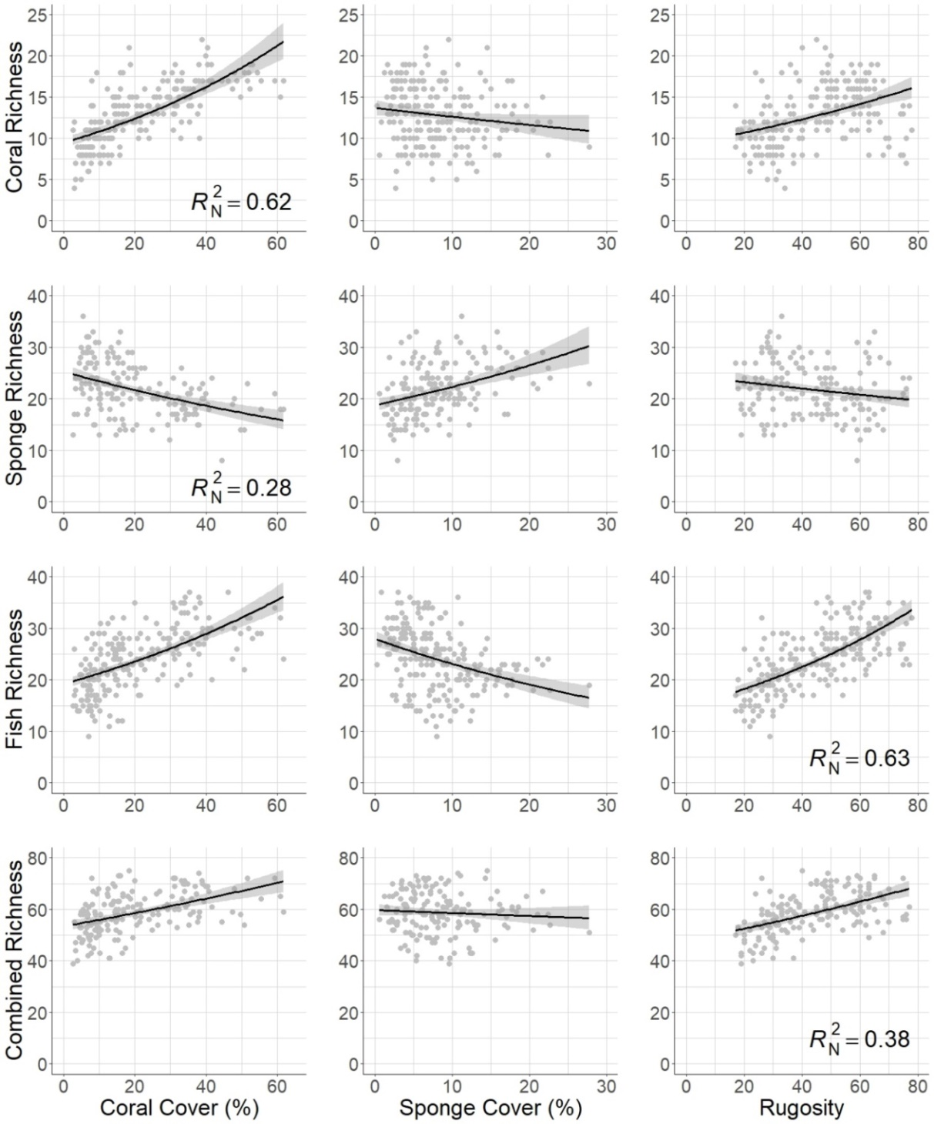

Figure 2. Lines represent smoothed conditional means using the negative binomial distribution and the formula y ~ x, where y is a target (rows) and x is a surrogate (columns). Shaded portions represent 95% confidence intervals of fitted values. Nagelkerke’s pseudo-r-squared values (*R*N2) are shown for the top (i.e. most competitive) surrogate for each target. Rugosity measured in centimeters. Data were collected from 8 coral reefs around Guana Island, BVI from 1992-2018.

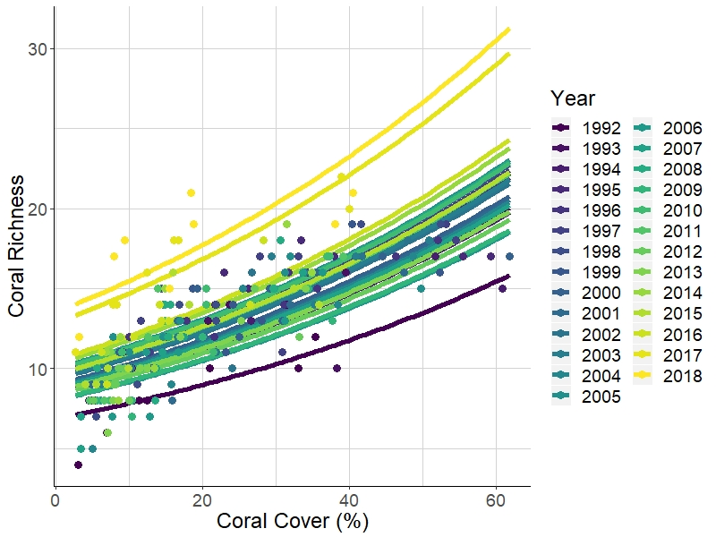

Figure 3. This figure helps to visualize changes in coral richness for a given amount of coral cover over a 27 year period. Solid lines represent predictions colored by year using the negative binomial distribution and the formula y ~ x + year, where y is coral richness, x is coral cover, and year is a categorical predictor. The formula y ~ x + year, with year as a trend, was the most competitive model to predict coral richness. Confidence intervals are not shown. Points represent observed values colored by year. Data were collected from 8 coral reefs around Guana Island, BVI from 1992-2018.

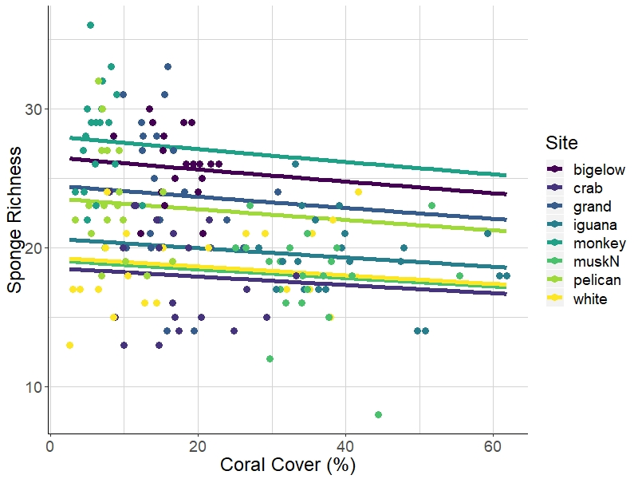

Figure 4. This figure helps to visualize large differences in sponge richness among sites for a given amount of coral cover. Solid lines represent predictions colored by site using the negative binomial distribution and the formula y ~ x + site, where y is sponge richness, x is coral cover, and site is a categorical predictor. The formula y ~ x + year + site, with year as a trend, was the most competitive model to predict sponge richness. Confidence intervals are not shown. Points represent observed values colored by year. Data were collected from 1992-2018 at 8 coral reefs around Guana Island, BVI.

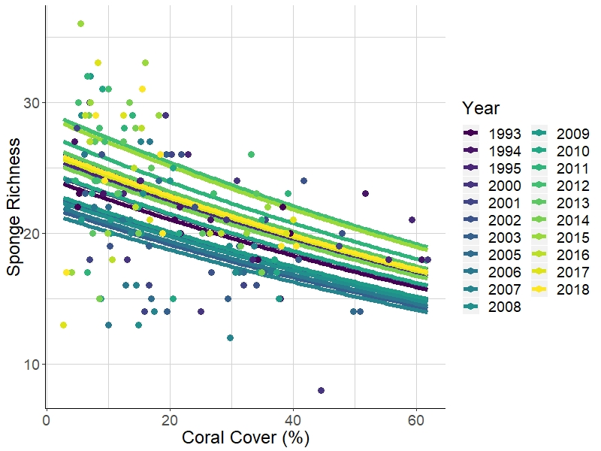

Figure 5. This figure helps to visualize changes in sponge richness for a given amount of coral cover over a 27 year period. Solid lines represent predictions colored by year using the negative binomial distribution and the formula y ~ x + year, where y is sponge richness, x is coral cover, and year is a categorical predictor. The formula y ~ x + year + site, with year as a trend, was the most competitive model to predict sponge richness. Confidence intervals are not shown. Points represent observed values colored by year. Data were collected from 8 coral reefs around Guana Island, BVI from 1992-2018.

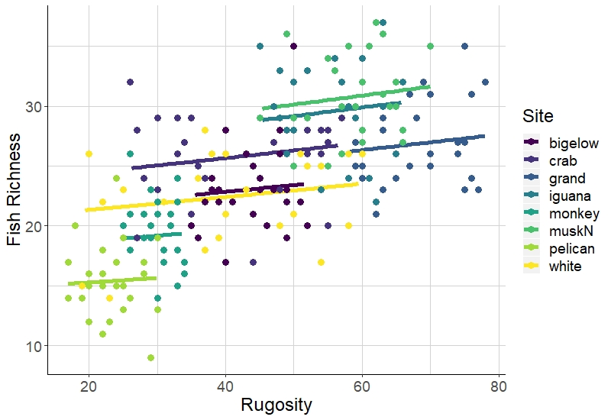

Figure 6. This figure helps to visualize differences in fish richness for a given amount of rugosity among 8 coral reefs around Guana Island, BVI. Solid lines represent predictions colored by site using the negative binomial distribution and the formula y ~ x + site, where y is fish richness, x is rugosity in cm, and site is a categorical predictor. Lines are truncated to correspond with the observed ranges of rugosity for each site. The formula y ~ x + site was the most competitive model to predict fish richness. Confidence intervals are not shown. Points represent observed values colored by year. Data were collected from 1992-2018.

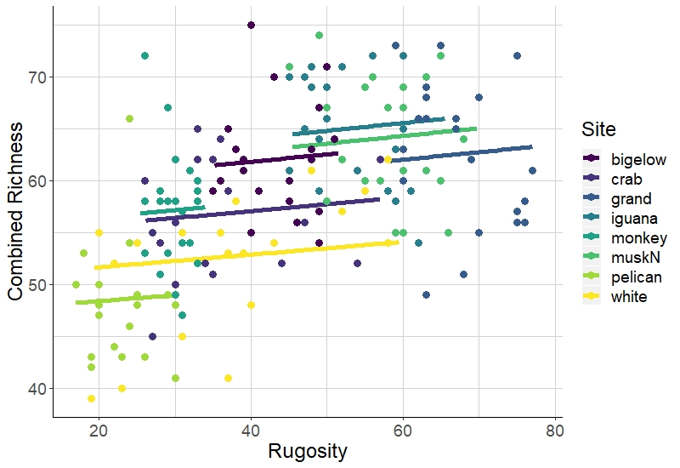

Figure 7. This figure helps to visualize differences in combined richness, as the sum of coral, fish, and sponge richness, for a given amount of rugosity among 8 coral reefs around Guana Island, BVI. Solid lines represent predictions colored by site using the negative binomial distribution and the formula y ~ x + site, where y is combined richness, x is rugosity in cm, and site is a categorical predictor. Lines are truncated to correspond with the observed ranges of rugosity for each site. The formula y ~ x + year + site, with year as a trend, was the most competitive model to predict combined richness. Confidence intervals are not shown. Points represent observed values colored by year. Data were collected from 1992-2018.

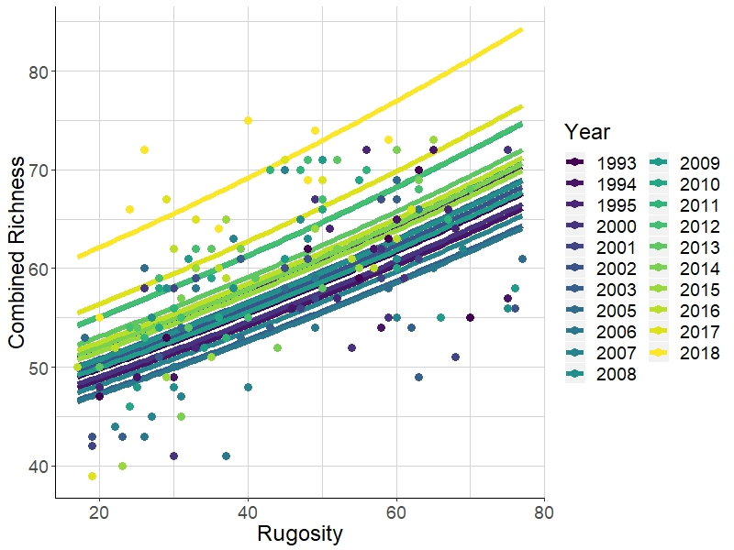

Figure 8. This figure helps to visualize changes in combined richness, as the sum of coral, fish, and sponge richness, for a given amount of rugosity over a 27 year period. Solid lines represent predictions colored by year using the negative binomial distribution and the formula y ~ x + year, where y is combined richness, x is rugosity in cm, and year is a categorical predictor. The formula y ~ x + year + site, with year as a trend, was the most competitive model to predict combined richness. Confidence intervals are not shown. Points represent observed values colored by year. Data were collected from 8 coral reefs around Guana Island, BVI from 1992-2018.

## Appendices

Table A.1. Fish species included in richness calculations.

|  |  |  |  |
| --- | --- | --- | --- |
| Fish species | Fish common name | Fish species cont. | Fish common name cont. |
| *Abudefduf saxatilis* | Sergeant major | *Hypoplectrus chlorurus* | yellowtail hamlet |
| *Acanthurus bahianus* | ocean surgeon | *Hypoplectrus guttavarius* | shy hamlet |
| *Acanthurus chirurgus* | doctorfish | *Hypoplectrus indigo* | indigo hamlet |
| *Acanthurus coeruleus* | blue tang | *Hypoplectrus nigricans* | black hamlet |
| *Aluterus scriptus* | scrawled filefish | *Hypoplectrus puella* | barred hamlet |
| *Amblycirrhitus pinos* | redspotted hawkfish | *Hypoplectrus sp.* | tan hamlet |
| *Anisotremus surinamensis* | black margate | *Hypoplectrus unicolor* | butter hamlet |
| *Anisotremus virginicus* | porkfish | *Inermia vittata* | boga |
| *Aulostomus maculatus* | trumpetfish | *Kyphosus sectatrix* | gray chub |
| *Balistes capriscus* | gray triggerfish | *Lachnolaimus maximus* | hogfish |
| *Balistes vetula* | queen triggerfish | *Lactophrys bicaudalis* | spotted trunkfish |
| *Bodianus rufus* | Spanish hogfish | *Lactophrys quadricornis* | scrawled cowfish |
| *Calamus calamus* | saucereye porgy | *Lactophrys triqueter* | smooth trunkfish |
| *Calamus pennatula* | pluma porgy | *Lutjanus apodus* | schoolmaster snapper |
| *Cantherhines macrocerus* | whitespotted filefish | *Lutjanus griseus* | gray snapper |
| *Cantherhines pullus* | orangespotted filefish | *Lutjanus jocu* | dog snapper |
| *Canthigaster rostrata* | sharp-nose puffer fish | *Lutjanus mahogoni* | mahogany snapper |
| *Centropyge argi* | cherubfish | *Lutjanus synagris* | lane snapper |
| *Chaetodipterus faber* | Atlantic spadefish | *Melichthys niger* | black durgon |
| *Chaetodon ocellatus* | spotfin butterflyfish | *Microspathodon chrysurus* | yellowtail damselfish |
| *Chaetodon sedentarius* | reef butterflyfish | *Monacanthus ciliatus* | fringed filefish |
| *Chaetodon striatus* | banded butterflyfish | *Monacanthus tuckeri* | slender filefish |
| *Chaetodon capistratus* | foureye butterflyfish | *Mulloidichthys martinicus* | yellow goatfish |
| *Chromis cyanea* | blue chromis | *Mycteroperca tigris* | tiger grouper |
| *Chromis insolata* | sunshinefish | *Mycteroperca venenosa* | yellowfin grouper |
| *Chromis multilineata* | brown chromis | *Nicholsina usta* | emerald parrotfish |
| *Clepticus parrae* | creole wrasse | *Ocyurus chrysurus* | yellowtail snapper |
| *Cryptotomus roseus* | bluelip parrotfish | *Odontoscion dentex* | reef croaker |
| *Diodon hystrix* | porcupinefish | *Pomacanthus arcuatus* | gray angelfish |
| *Epinephelus adscensionis* | rock hind | *Pomacanthus paru* | French angelfish |
| *Epinephelus guttatus* | red hind | *Pomacentrus diencaeus* | longfin damselfish |
| *Epinephelus cruentatus* | graysby | *Pomacentrus leucostictus* | beaugregory |
| *Epinephelus fulva* | coney | *Pomacentrus variabilis* | cocoa damselfish |
| *Epinephelus striatus* | Nassau grouper | *Pomacentrus fuscus* | dusky damselfish |
| *Equetus acuminatus* | high-hat | *Pomacentrus partitus* | bicolor damselfish |
| *Equetus lanceolatus* | jacknife fish | *Pomacentrus planifrons* | threespot damselfish |
| *Equetus punctatus* | spotted drum | *Pseudupeneus maculatus* | spotted goatfish |
| *Gerres cinereus* | yellowfin mojarra | *Pterois volitans* | lionfish |
| *Gramma loreto* | fairy basslet | *Scarus coeruleus* | blue parrotfish |
| *Haemulon aurolineatum* | tomtate grunt | *Scarus croicensis* | striped parrotfish |
| *Haemulon carbonarium* | Caesar grunt | *Scarus guacamaia* | rainbow parrotfish |
| *Haemulon chrysargyreum* | smallmouth grunt | *Scarus taeniopterus* | princess parrotfish |
| *Haemulon flavolineatum* | French grunt | *Scarus vetula* | queen parrotfish |
| *Haemulon macrostomum* | Spanish grunt | *Serranus baldwini* | lantern bass |
| *Haemulon melanurum* | cottonwick grunt | *Serranus tabacarius* | tobacco fish |
| *Haemulon plumierii* | white grunt | *Serranus tigrinus* | harlequin bass |
| *Haemulon sciurus* | blue striped grunt | *Serranus tortugarum* | chalk bass |
| *Haemulon sp. unidentified* | unidentified grunt | *Sparisoma atomarium* | greenblotch parrotfish |
| *Haemulon striatum* | striped grunt | *Sparisoma aurofrenatum* | redband parrotfish |
| *Halichoeres bivittatus* | slippery dick | *Sparisoma chrysopterum* | redtail parrotfish |
| *Halichoeres cyanocephalus* | yellowcheek wrasse | *Sparisoma radians* | bucktooth parrotfish |
| *Halichoeres garnoti* | yellowhead wrasse | *Sparisoma rubripinne* | yellowtail parrotfish |
| *Halichoeres maculipinna* | clown wrasse | *Sparisoma viride* | stoplight parrotfish |
| *Halichoeres pictus* | rainbow wrasse | *Sphoeroides dorsalis* | marbled puffer |
| *Halichoeres poeyi* | blackear wrasse | *Sphoeroides spengleri* | bandtail puffer |
| *Halichoeres radiatus* | puddingwife | *Synodus intermedius* | sand diver |
| *Holacanthus ciliaris* | queen angelfish | *Synodus saurus* | bluestripe lizardfish |
| *Holacanthus tricolor* | rock beauty | *Synodus synodus* | red lizardfish |
|  |  | *Thalassoma bifasciatum* | bluehead wrasse |

Table A.2. Benthic species included in richness calculations. * indicates recognizable taxonomic unit.

|  |  |
| --- | --- |
| **Coral species** | **Sponge species** |
| *Acropora cervicornis* | *\*Agelas citrina*, *Agelas clathrodes*, or *Clathria faviformis* |
| *Acropora palmata* | *Agelas conifera* |
| *Agaricia agaricites* | *\*Agelas* spp. |
| *\*Agaricia* spp. (mostly *Agaricia humilis* | *\*Aiolochroia crassa* and *Verongula rigida* |
| and *Agaricia lamarcki*) | *Amphimedon compressa* |
| *Cladocora arbuscula* | *\*Amphimedon* sp. (maybe *Amphimedon complanata*) |
| *Colpophyllia natans* | *Amphimedon viridis* |
| *Dendrogyra cylindrus* | *\*Aplysina fistularis*, *Aplysina fulva*, and *Aplysina insularis* |
| *Diploria labyrinthiformis* | *Aplysina cauliformis* |
| *\*Diploria strigosa* and *Diploria clivosa* | *\*Aplysina lacunosa*, *Suberea* sp., and *Verongula reiswigi* |
| *Dichocoenia stokesi* | *\*Artemisina melana* or *Iotrochota arenosa* |
| *Eusmilia fastigiata* | *Black, spiny, purple exudate, but not slimy |
| *Favia fragum* | *Breadcrumb (*Calyx podatypa*, *Svenzea* |
| *Helioceris cucullata* | *cristinae*, or *Svenzea zeai*) |
| *Isophyllia sinuosa* | *Callyspongia fallax* |
| *Manicina areolata* | *Like *Callyspongia fallax* but soft with pinched tube ends |
| *Montastraea cavernosa* | *Callyspongia plicifera* |
| *\*Madracis mirabilis* and *Madracis decactis* | *Callyspongia vaginalis* |
| *Meandrina meandrites* | *Cervicornia cuspidifera* |
| *\*Montastraea annularis, M. franksi, M. faveolata* | *Chondrilla caribensis* |
| (genus name now Orbicella) | *Cinachyrella kuekenthali* |
| *Mussa angulosa* | *Clathria venosa* |
| *\*Mycetophyllia ferox, Mycetophyllia lamarckiana* | *Clathria virgultosa* |
| *\*Oculina* spp. | *Cliona delitrix* |
| *Porites astreoides* | *Cliona laticavicola* |
| *Porites colonensis* | *Cliona varians* |
| *Porites furcata* | *\*Cribochalina vasculum* and *Petrosia pellasarca* |
| *Porites porites* | *Desmapsamma anchorata* |
| *\*Scolymia* spp. | *Dictyonella funicularis* |
| *\*Siderastrea siderea* and *Siderastrea radians* | *Dragmacidon reticulatum* |
| *Solenastrea bournoni* | *Dysidea janiae* |
| *Stephanocoenia intersepta* | *\*Dysidea* sp. (maybe etheria) |
|  | *Ectyoplasia ferox* |
|  | *Halisarca caerulea* |
|  | *\*Higginsia coralloides* (may include *Ptilocaulis walpersii*) |
|  | *\*Hyrtios* sp. or *Spheciospongia vesparium* |
|  | *Iotrochota birotulata* |
|  | *\*Iotrochota* sp. |
|  | *Ircinia campana* |
|  | *Ircinia felix* |
|  | *Ircinia strobilina* |
|  | *Maybe "Ircinia smooth" or Spongia |
|  | *Monanchora arbuscula* |
|  | *Mycale laevis* |
|  | *Mycale laxissima* |
|  | *Neofibularia nolitangere* |
|  | *\*Neopetrosia proxima* (may include |
|  | *Xestospongia subtriangularis*) |
|  | *\*Niphates erecta* (may include *Niphates amorpha*) |
|  | *\*Niphates* sp. or *Lissodendoryx* sp.? |
|  | *Orange encrusting |
|  | *Pandaros acanthifolium* |
|  | *\*Plakortis* sp. |
|  | *Red Encrusting |
|  | *Scopalina ruetzleri* |
|  | *\*Spirastrella coccinea* and *Spirastrella hartmani* |
|  | *Spongosorites coralliphaga* |
|  | *Tectitethya crypta* |
|  | *Unidentified |
|  | *Xestospongia muta* |

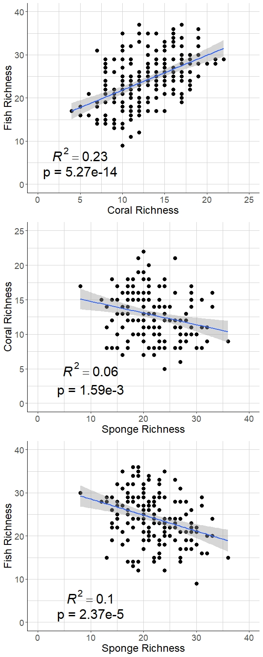

Figure A.3. Basic associations between the targets. Lines represent smoothed conditional means using a generalized linear model and the formula y ~ x. Shaded portions represent 95% confidence intervals of fitted values. Traditional r-squared (*R*2) and p-values are shown. Data were collected from 8 coral reefs around Guana Island, BVI from 1992-2018.

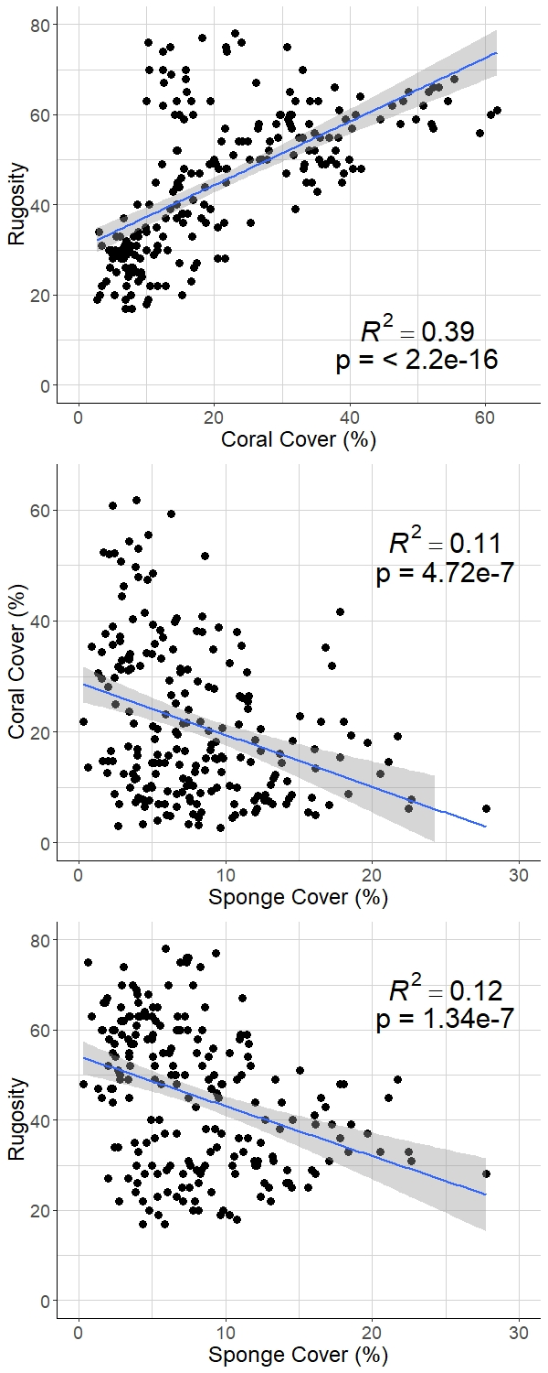

Figure A.4. Basic associations between the surrogates. Lines represent smoothed conditional means using a generalized linear model and the formula y ~ x. Shaded portions represent 95% confidence intervals of fitted values. Traditional r-squared (*R*2) and p-values are shown. Rugosity measured in centimeters. Data were collected from 8 coral reefs around Guana Island, BVI from 1992-2018.

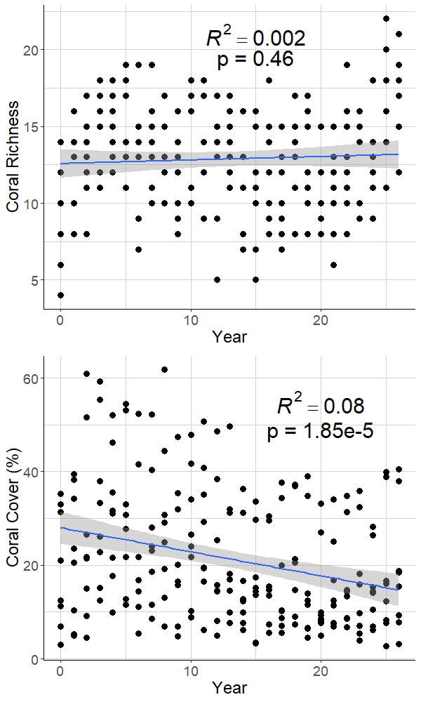

Figure A.5. Coral richness and coral cover over the 27 year study period from 1992-2018, where year 0 is 1992. Lines represent smoothed conditional means using a generalized linear model and the formula y ~ x, where x is year as a trend. Shaded portions represent 95% confidence intervals of fitted values. Traditional r-squared (*R*2) and p-values are shown. Data were collected from 8 coral reefs around Guana Island, BVI.

Appendix 6. Model output for the most competitive model for predicting coral richness including a term for year. Estimates calculated using the negative binomial distribution and the formula y ~ x + year, where y coral richness, x is coral cover, and year is a trend. Data were collected from 8 coral reefs around Guana Island, BVI from 1992-2018.

Coefficients:

Estimate Std. Error z value Pr(>|z|)

(Intercept) 2.0751 0.0571 36.350 < 2e-16 ***

Percent_Coral_Cover 0.0152 0.0013 11.275 < 2e-16 ***

Year 0.0103 0.0026 4.012 6.03e-05 ***

---

Significance codes: 0 ‘***’ 0.001 ‘**’ 0.01 ‘*’ 0.05 ‘.’ 0.1 ‘ ’ 1

Appendix 7. Model output for the most competitive model for predicting coral richness including terms for year and the interaction between coral cover and year. Estimates calculated using the negative binomial distribution and the formula y ~ x + year + x * year, where y coral richness, x is coral cover, and year is a trend. Data were collected from 8 coral reefs around Guana Island, BVI from 1992-2018.

Coefficients:

Estimate Std. Error z value Pr(>|z|)

(Intercept) 2.1163 0.0757 27.950 < 2e-16 ***

Percent_Coral_Cover 0.0136 0.0024 5.763 8.25e-09 ***

Year 0.0070 0.0048 1.478 0.139

Percent_Coral_Cover:Year 0.0001 0.0002 0.823 0.411

---

Significance codes: 0 ‘***’ 0.001 ‘**’ 0.01 ‘*’ 0.05 ‘.’ 0.1 ‘ ’ 1

Appendix 8. Model output for the most competitive model for predicting sponge richness including terms for year and site. Estimates calculated using the negative binomial distribution and the formula y ~ x + year + site, where y is sponge richness, x is coral cover, year is a trend, and site is a categorical predictor. Data were collected from 8 coral reefs around Guana Island, BVI from 1992-2018.

Coefficients:

Estimate Std. Error z value Pr(>|z|)

(Intercept) 3.0204 0.0901 33.511 < 2e-16 ***

Percent_Coral_Cover 0.0041 0.0029 1.443 0.148955

Year 0.0106 0.0027 3.885 0.000102 ***

Sitecrab -0.3709 0.0688 -5.392 6.95e-08 ***

Sitegrand -0.0802 0.0628 -1.276 0.201957

Siteiguana -0.3964 0.0964 -4.110 3.96e-05 ***

Sitemonkey 0.1110 0.0671 1.655 0.097956 .

SitemuskN -0.4417 0.0862 -5.124 2.99e-07 ***

Sitepelican -0.0650 0.0694 -0.937 0.348668

Sitewhite -0.3335 0.0673 -4.957 7.16e-07 ***

---

Significance codes: 0 ‘***’ 0.001 ‘**’ 0.01 ‘*’ 0.05 ‘.’ 0.1 ‘ ’ 1

Appendix 9. Model output for the most competitive model for predicting fish richness including terms for site. Estimates calculated using the negative binomial distribution and the formula y ~ x + site, where y is fish richness, x is rugosity in cm, and site is a categorical predictor. Data were collected from 8 coral reefs around Guana Island, BVI from 1992-2018.

Coefficients:

Estimate Std. Error z value Pr(>|z|)

(Intercept) 3.0322 0.0908 33.394 < 2e-16 ***

Rugosity 0.0024 0.0019 1.309 0.190702

Sitecrab 0.1161 0.0552 2.103 0.035468 *

Sitegrand 0.0932 0.0706 1.321 0.186509

Siteiguana 0.2199 0.0575 3.822 0.000132 ***

Sitemonkey -0.1508 0.0648 -2.325 0.020081 *

SitemuskN 0.2524 0.0600 4.206 2.60e-05 ***

Sitepelican -0.3540 0.0739 -4.790 1.67e-06 ***

Sitewhite -0.0193 0.0572 -0.337 0.736017

---

Significance codes: 0 ‘***’ 0.001 ‘**’ 0.01 ‘*’ 0.05 ‘.’ 0.1 ‘ ’ 1

Appendix 10. Model output for the most competitive model for predicting combined richness, as the sum of coral, fish, and sponge richness, including terms for year and site. Estimates calculated using the negative binomial distribution and the formula y ~ x + year + site, where y is combined richness, x is rugosity in cm, year is a trend, and site is a categorical predictor. Data were collected from 8 coral reefs around Guana Island, BVI from 1992-2018.

Coefficients:

Estimate Std. Error z value Pr(>|z|)

(Intercept) 3.8663 0.0991 39.023 < 2e-16 ***

Rugosity 0.0043 0.0018 2.383 0.017150 *

Year 0.0052 0.0017 3.002 0.002678 **

Sitecrab -0.0706 0.0418 -1.690 0.090956 .

Sitegrand -0.0986 0.0594 -1.659 0.097162 .

Siteiguana 0.0016 0.0434 0.037 0.970659

Sitemonkey -0.0275 0.0469 -0.587 0.556993

SitemuskN -0.0314 0.0474 -0.661 0.508411

Sitepelican -0.1573 0.0565 -2.783 0.005388 **

Sitewhite -0.1422 0.0423 -3.366 0.000764 ***

---

Significance codes: 0 ‘***’ 0.001 ‘**’ 0.01 ‘*’ 0.05 ‘.’ 0.1 ‘ ’ 1

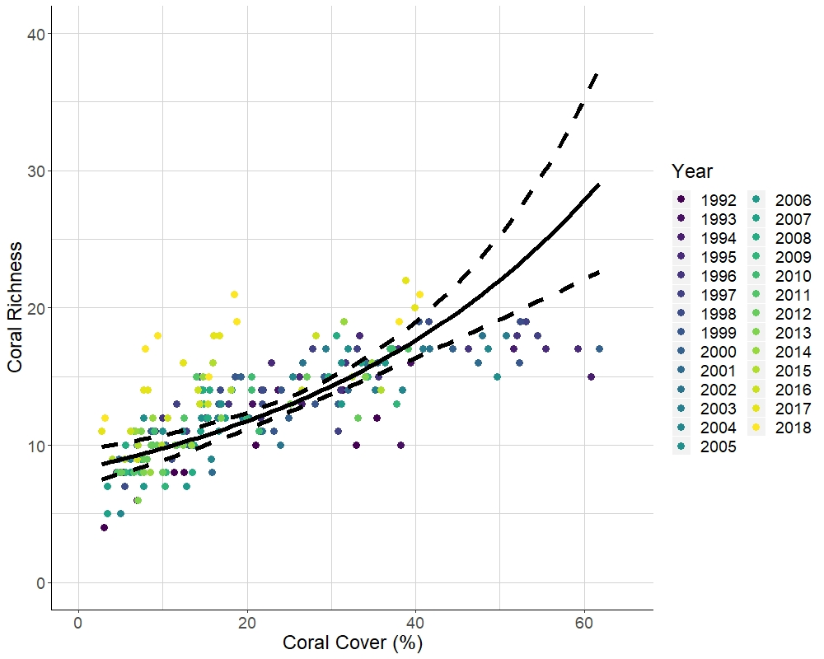

Figure #3. Competitive models for predicting coral richness included a term for year. Solid line represents predictions using the negative binomial distribution and the formula y ~ x + year + x * year, where y coral richness, x is coral cover, and year is a trend. Dashed lines represent 95% confidence intervals of fitted values. Points represent observed values colored by year. Data were collected from 8 coral reefs around Guana Island, BVI from 1992-2018.

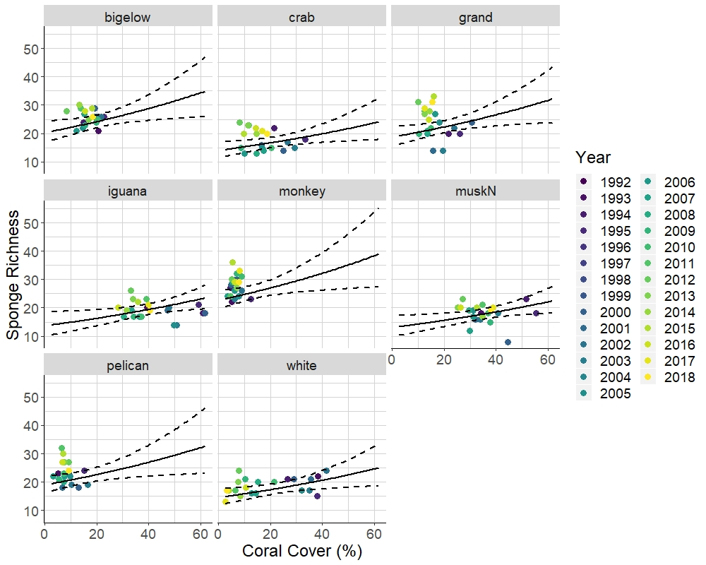

Figure #4. The most competitive model for predicting sponge richness included terms for year and site. Each panel represents one of 8 coral reefs around Guana Island, BVI. Solid lines represent predictions using the negative binomial distribution and the formula y ~ x + year + site, where y is sponge richness, x is coral cover, year is a trend, and site is a categorical predictor. Dashed lines represent 95% confidence intervals of fitted values. Points represent observed values colored by year. Data were collected from 1992-2018.

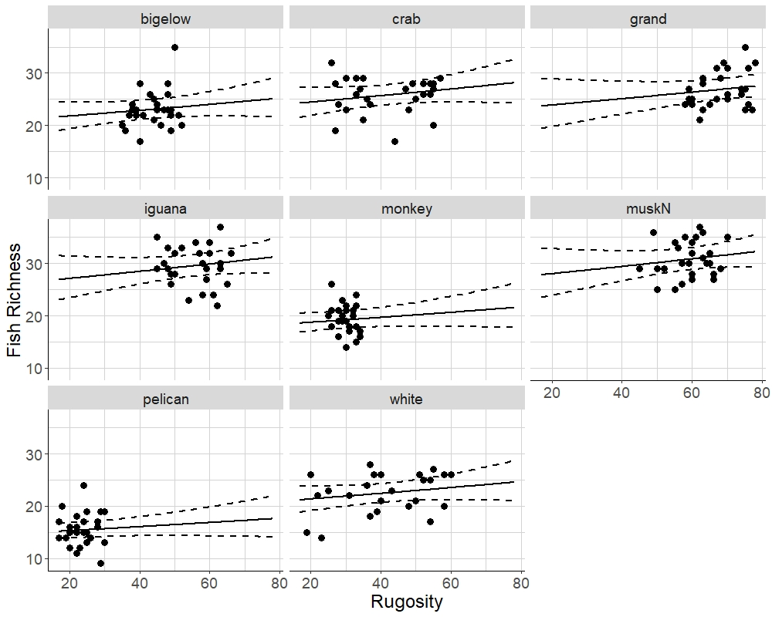

Figure #5. The most competitive model for predicting fish richness included a term for site. Each panel represents one of 8 coral reefs around Guana Island, BVI. Solid lines represent predictions using the negative binomial distribution and the formula y ~ x + site, where y is fish richness, x is rugosity in cm, and site is a categorical predictor. Dashed lines represent 95% confidence intervals of fitted values. Points represent observed values. Data were collected from 1992-2018.

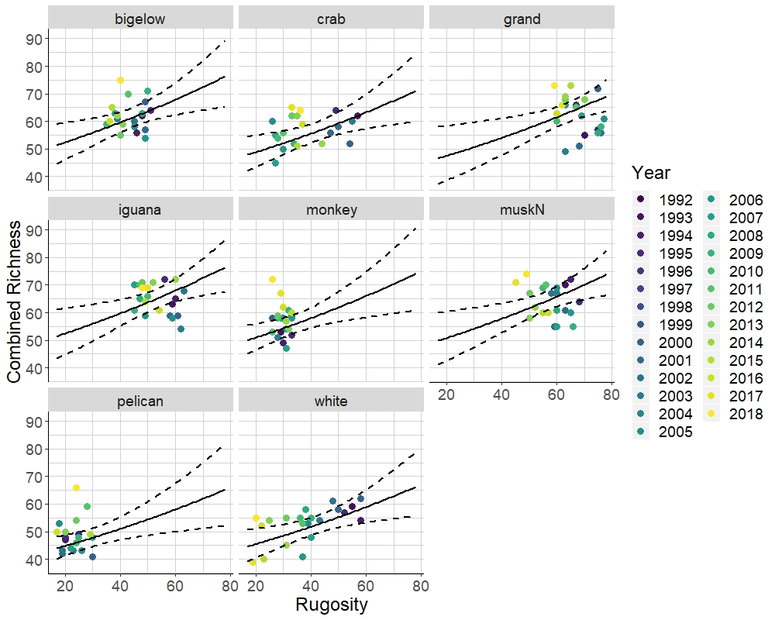

Figure #. The most competitive model for predicting combined richness, as the sum of coral, fish, and sponge richness, included terms for year and site. Each panel represents one of 8 coral reefs around Guana Island, BVI. Solid lines represent predictions using the negative binomial distribution and the formula y ~ x + year + site, where y is combined richness, x is rugosity in cm, year is a trend, and site is a categorical predictor. Dashed lines represent 95% confidence intervals of fitted values. Points represent observed values colored by year. Data were collected from 1992-2018.

1. Department of Natural Resources Science, University of Rhode Island, Kingston, RI 02881, USA ; nicole-keefner@uri.edu
2. Department of Natural Resources Science, University of Rhode Island, Kingston, RI 02881, USA; gforrester@uri.edu